# [***80 FR 3316***](https://advance.lexis.com/api/document?collection=administrative-codes&id=urn:contentItem:5F4C-SNH0-006W-80H0-00000-00&context=)

Vol. 80, No. 014, Part II, Thursday, January 22, 2015

Proposed Rules

**Reporter**

80 FR 3316 *

***Federal Register* > *2015* > *January* > *Thursday, January 22, 2015* > *Proposed Rules* > *DEPARTMENT OF THE INTERIOR (DOI) -- United States Fish and Wildlife Service (FWS)***

**Title:** **Endangered and Threatened Wildlife and Plants; Designation of Critical Habitat for Consolea corallicola (Florida Semaphore Cactus) and Harrisia aboriginum (Aboriginal Prickly-Apple)**

**Action:**  Proposed rule.

**Agency**

DEPARTMENT OF THE INTERIOR (DOI) > United States Fish and Wildlife Service (FWS)

**Identifier:** **[Docket No. FWS-R4-ES-2014-0057: 4500030113]** > **RIN 1018-AZ92**

**Administrative Code Citation**

**50 CFR Part 17**

**Synopsis**

**SUMMARY:** We, the U.S. Fish and Wildlife Service, propose to designate critical habitat for *Consolea corallicola* (Florida semaphore cactus) and *Harrisia aboriginum* (aboriginal prickly-apple) under the Endangered Species Act (Act). In total, approximately 4,411 acres (1,785 hectares) for *Consolea corallicola* in Miami-Dade and Monroe Counties, Florida; and 3,444 acres (1,394 hectares) for *Harrisia aboriginum* in Manatee, Charlotte, Sarasota, and Lee Counties, Florida, fall within the boundaries of the proposed critical habitat designations. We also announce the availability of a draft economic analysis of the proposed designation for these species.

**Text**

**SUPPLEMENTARY INFORMATION:**

**Executive Summary**

*Why we need to publish a rule.* Under the Endangered Species Act (Act), when we determine that any species is threatened or endangered, we must designate critical habitat, to the maximum extent prudent and determinable. Designations and revisions of critical habitat can only be completed by issuing a rule. We listed *Consolea corallicola* (Florida semaphore cactus) and *Harrisia aboriginum* (aboriginal prickly-apple) as endangered species under the Act on October 24, 2013 [*(78 FR 63795).*](https://advance.lexis.com/api/document?collection=administrative-codes&id=urn:contentItem:59NC-0850-006W-84H4-00000-00&context=)

*What this rule contains.* This rule consists of a proposed rule for designation of critical habitat for two endangered plant species, *Consolea corallicola* and *Harrisia aboriginum.*

*The basis for our action.* Section 4(b)(2) of the Act states that the Secretary shall designate critical habitat on the basis of the best available scientific data after taking into consideration the economic impact, national security impact, and any other relevant impact of specifying any particular area as critical habitat. The Secretary may exclude an area from critical habitat if she determines that the benefits of such exclusion outweigh the benefits of specifying such area as part of the critical habitat, unless she determines, based on the best scientific data available, that the failure to designate such area as critical habitat will result in the extinction of the species.

*We have prepared an economic analysis of the proposed designations of critical habitat.* We are preparing an analysis of the economic impacts of the proposed critical habitat designation and related factors. We hereby announce the availability of the draft economic analysis and seek additional public review and comment.

*We will seek peer review.* We are seeking comments from independent specialists to ensure that our critical habitat designation proposal is based on scientifically sound data and analyses. We have invited these peer reviewers to comment on our specific assumptions and conclusions in this critical habitat proposal. Because we will consider all comments and information received during the comment period, our final determinations may differ from this proposal.

**Information Requested**

We intend that any final action resulting from this proposed rule will be based on the best scientific and commercial data available and be as accurate and as effective as possible. Therefore, we request comments or information from other concerned government agencies, the scientific community, industry, or any other interested party concerning this proposed rule. We particularly seek comments concerning:

(1) The reasons why we should or should not designate habitat as "critical habitat" under section 4 of the Act [*(16 U.S.C. 1531*](https://advance.lexis.com/api/document?collection=statutes-legislation&id=urn:contentItem:4YF7-GK21-NRF4-416B-00000-00&context=) *et seq.*) including whether there are threats to these species from human activity, the degree of which can be expected to increase due to the designation, and whether that increase in threat outweighs the benefit of designation such that the designation of critical habitat may not be prudent.

(2) Specific information on:

(a) The amount and distribution of *Consolea corallicola* and *Harrisia aboriginum* habitat,

(b) What may constitute "physical or biological features essential to the conservation of the species," within the geographical range currently occupied by the species,

(c) What areas, that were occupied at the time of listing (or are currently occupied) and that contain features **[*3317]** essential to the conservation of the species, should be included in the designation and why,

(d) Special management considerations or protections that may be needed in the critical habitat areas we are proposing, including managing for the potential effects of climate change, and

(e) What areas not occupied at the time of listing are essential for the conservation of the species and why.

(3) Land use designations and current or planned activities in the subject areas and their possible impacts on proposed critical habitat.

(4) Information on the projected and reasonably likely impacts of climate change on *Consolea corallicola* and *Harrisia aboriginum* and proposed critical habitat.

(5) Any probable economic, national security, or other relevant impacts of designating any area that may be included in the final designation; in particular, any impacts on small entities or families, and the benefits of including or excluding areas that exhibit these impacts.

(6) Information on the extent to which the description of economic impacts in the draft economic analysis is a reasonable estimate of the likely economic impacts.

(7) The likelihood of adverse social reactions to the designation of critical habitat, as discussed in the associated documents of the draft economic analysis, and how the consequences of such reactions, if likely to occur, would relate to the conservation and regulatory benefits of the proposed critical habitat designation.

(8) Whether any specific areas we are proposing for critical habitat designation should be considered for exclusion under section 4(b)(2) of the Act, and whether the benefits of potentially excluding any specific area outweigh the benefits of including that area under section 4(b)(2) of the Act.

(9) Whether we could improve or modify our approach to designating critical habitat in any way to provide for greater public participation and understanding, or to better accommodate public concerns and comments.

You may submit your comments and materials concerning this proposed rule by one of the methods listed in **ADDRESSES**. We request that you send comments only by the methods described in **ADDRESSES**.

All comments submitted electronically via [*http://www.****regulations****.gov*](http://www.regulations.gov) will be presented on the Web site in their entirety as submitted. For comments submitted via hard copy, we will post your entire comment--including your personal identifying information--on [*http://www.****regulations****.gov*](http://www.regulations.gov)*.* You may request at the top of your document that we withhold personal information such as your street address, phone number, or email address from public review; however, we cannot guarantee that we will be able to do so.

Comments and materials we receive, as well as supporting documentation we used in preparing this proposed rule, will be available for public inspection on [*http://www.****regulations****.gov*](http://www.regulations.gov)*,* or by appointment, during normal business hours, at the U.S. Fish and Wildlife Service, South Florida Ecological Services Office (see **FOR FURTHER INFORMATION CONTACT**).

**Previous Federal Actions**

Previous Federal actions for *Consolea corallicola* and *Harrisia aboriginum* are outlined in our proposed and final rules to list both species as endangered species published in the **Federal Register** on October 11, 2012 [*(77 FR 61836),*](https://advance.lexis.com/api/document?collection=administrative-codes&id=urn:contentItem:56SS-DCM0-006W-8110-00000-00&context=) and October 24, 2013 [*(78 FR 63796),*](https://advance.lexis.com/api/document?collection=administrative-codes&id=urn:contentItem:59NC-0850-006W-84H5-00000-00&context=) respectively.

*Summary of Biological Status for Consolea corallicola* and *Harrisia aboriginum*

It is our intent to discuss below only those topics directly relevant to the designation of critical habitat for *Consolea corallicola* and *Harrisia aboriginum* in this section of the proposed rule. For more information on *C. corallicola* and *H. aboriginum* taxonomy, life history, habitat, population descriptions, and factors affecting the species, please refer to the proposed listing rule published October 11, 2012 [*(77 FR 61836),*](https://advance.lexis.com/api/document?collection=administrative-codes&id=urn:contentItem:56SS-DCM0-006W-8110-00000-00&context=) in the **Federal Register**, and the final listing rule published October 24, 2013 [*(78 FR 63796),*](https://advance.lexis.com/api/document?collection=administrative-codes&id=urn:contentItem:59NC-0850-006W-84H5-00000-00&context=) in the **Federal Register** .

*Consolea corallicola* and *Harrisia aboriginum* (Family: Cactaceae) are large tree- or shrub-like cacti and are endemic to South Florida. *C. corallicola* occurs in Miami-Dade and Monroe Counties in coastal berms, rockland hammocks, and buttonwood forests on sandy or limestone rockland soils with little organic matter. *H. aboriginum* occurs in Manatee, Sarasota, Charlotte, and Lee Counties on coastal berms, coastal strand, coastal grasslands, and maritime hammocks, with a sand substrate. It also occurs on shell mounds with a calcareous shell substrate.

Habitat

*Consolea corallicola* occurs in rockland hammocks (Small 1930, pp. 25-26; Benson 1982, p. 531), coastal berm, and buttonwood forests (Bradley and Gann 1999, p. 77; Gann *et al.* 2002, p. 480; Higgins 2007, pers. comm.). *Consolea corallicola* occurs on sandy soils and limestone rockland soils with little organic matter (Small 1930, pp. 25-26) and seems to prefer areas where canopy cover and sun exposure are moderate (Grahl and Bradley 2005, p. 4). Detailed descriptions of these habitats are presented in the proposed listing rule for *Chromolaena frustrata, Consolea corallicola,* and *Harrisia aboriginum* (October 11, 2012; [*77 FR 61836),*](https://advance.lexis.com/api/document?collection=administrative-codes&id=urn:contentItem:56SS-DCM0-006W-8110-00000-00&context=) with a revised description of buttonwood forests provided in the final listing rule for these plants (October 24, 2013; [*78 FR 63796).*](https://advance.lexis.com/api/document?collection=administrative-codes&id=urn:contentItem:59NC-0850-006W-84H5-00000-00&context=)

*Harrisia aboriginum* occurs on coastal berms, coastal strand, coastal grasslands and maritime hammocks, with a sand substrate. It also occurs on shell mounds with a calcareous shell substrate (Bradley et al. 2004, pp. 4, 14). Detailed descriptions of these habitats are presented in the proposed listing rule for *Chromolaena frustrata, Consolea corallicola,* and *Harrisia aboriginum* (October 11, 2012; [*77 FR 61836).*](https://advance.lexis.com/api/document?collection=administrative-codes&id=urn:contentItem:56SS-DCM0-006W-8110-00000-00&context=)

Distribution and Range

The current range of *Consolea corallicola* includes two naturally occurring populations and five reintroduced populations in Miami-Dade and Monroe Counties, Florida. These populations account for fewer than 1,500 plants, and all are located on conservation lands. Wild populations, on Key Largo and Big Pine Key in the Florida Keys, were lost more than a decade ago by development and collecting by cactus enthusiasts. *C. corallicola* has subsequently been reintroduced to Key Largo and Big Pine Key.

The current range of *Harrisia aboriginum* includes 12 populations in Charlotte, Sarasota, and Lee Counties, Florida. Plants occur in eight public and private conservation areas, as well as two County parcels not managed for conservation and at least three unprotected private parcels. In total, the species was represented by an estimated 300 to 500 individuals in 2007, when population sizes were last estimated. Populations formerly known from Terra Ceia in Manatee County and Cayo Costa Island in Lee County are extirpated (no longer in existence). A large population on Longboat Key has been reduced from 226 individuals in 1981 to 5 in 2007 due to development.

Although *Consolea corallicola* and *Harrisia aboriginum* populations occur largely within public conservation lands, threats remain from a wide array of natural and anthropogenic sources. **[*3318]** Habitat loss, storm surge, poaching, disease, predation, and climate change are the imminent threats to these cacti [*(78 FR 63796).*](https://advance.lexis.com/api/document?collection=administrative-codes&id=urn:contentItem:59NC-0850-006W-84H5-00000-00&context=)

*Critical Habitat*

Background

Critical habitat is defined in section 3 of the Act as:

(1) The specific areas within the geographical area occupied by the species, at the time it is listed in accordance with the Act, on which are found those physical or biological features:

(a) Essential to the conservation of the species, and

(b) Which may require special management considerations or protection; and

(2) Specific areas outside the geographical area occupied by the species at the time it is listed, upon a determination that such areas are essential for the conservation of the species.

Conservation, as defined under section 3 of the Act, means to use and the use of all methods and procedures that are necessary to bring an endangered or threatened species to the point at which the measures provided pursuant to the Act are no longer necessary. Such methods and procedures include, but are not limited to, all activities associated with scientific resources management such as research, census, law enforcement, habitat acquisition and maintenance, propagation, live trapping, and transplantation, and, in the extraordinary case where population pressures within a given ecosystem cannot be otherwise relieved, may include regulated taking.

Critical habitat receives protection under section 7 of the Act through the requirement that Federal agencies ensure, in consultation with the Service, that any action they authorize, fund, or carry out is not likely to result in the destruction or adverse modification of critical habitat. The designation of critical habitat does not affect land ownership or establish a refuge, wilderness, reserve, preserve, or other conservation area. Such designation does not allow the government or public to access private lands. Such designation does not require implementation of restoration, recovery, or enhancement measures by non-Federal landowners. Where a landowner requests Federal agency funding or authorization for an action that may affect a listed species or critical habitat, the consultation requirements of section 7(a)(2) of the Act would apply, but even in the event of a destruction or adverse modification finding, the obligation of the Federal action agency and the landowner is not to restore or recover the species, but to implement reasonable and prudent alternatives to avoid destruction or adverse modification of critical habitat.

Under the first prong of the Act's definition of critical habitat, areas within the geographical area occupied by the species at the time it was listed are included in a critical habitat designation if they contain physical or biological features (1) which are essential to the conservation of the species and (2) which may require special management considerations or protection. For these areas, critical habitat designations identify, to the extent known using the best scientific and commercial data available, those physical or biological features that are essential to the conservation of the species (such as space, food, cover, and protected habitat). In identifying those physical or biological features within an area, we focus on the principal biological or physical constituent elements (primary constituent elements such as roost sites, nesting grounds, seasonal wetlands, water quality, tide, soil type) that are essential to the conservation of the species. Primary constituent elements are those specific elements of the physical or biological features that provide for a species' life-history processes and are essential to the conservation of the species.

Under the second prong of the Act's definition of critical habitat, we may designate critical habitat in areas outside the geographical area occupied by the species at the time it is listed, upon a determination that such areas are essential for the conservation of the species. For example, an area currently occupied by the species but that was not occupied at the time of listing may be essential for the conservation of the species and may be included in the critical habitat designation. We designate critical habitat in areas outside the geographical area occupied by a species only when a designation limited to its range would be inadequate to ensure the conservation of the species.

Section 4 of the Act requires that we designate critical habitat on the basis of the best scientific data available. Further, our Policy on Information Standards Under the Endangered Species Act (published in the **Federal Register** on July 1, 1994 [*(59 FR 34271)),*](https://advance.lexis.com/api/document?collection=administrative-codes&id=urn:contentItem:3SHC-7K20-006W-9232-00000-00&context=) the Information Quality Act (section 515 of the Treasury and General Government Appropriations Act for Fiscal Year 2001 (*Pub. L. 106-554*; H.R. 5658)), and our associated Information Quality Guidelines, provide criteria, establish procedures, and provide guidance to ensure that our decisions are based on the best scientific data available. They require our biologists, to the extent consistent with the Act and with the use of the best scientific data available, to use primary and original sources of information as the basis for recommendations to designate critical habitat.

When we are determining which areas should be designated as critical habitat, our primary source of information is generally the information developed during the listing process for the species. Additional information sources may include, but are not limited to, the recovery plan for the species, articles in peer-reviewed journals, conservation plans developed by States and counties, scientific status surveys and studies, biological assessments, other unpublished materials, or experts' opinions or personal knowledge.

Habitat is dynamic, and species may move from one area to another over time. We recognize that critical habitat designated at a particular point in time may not include all of the habitat areas that we may later determine are necessary for the recovery of the species. For these reasons, a critical habitat designation does not signal that habitat outside the designated area is unimportant or may not be needed for recovery of the species. Areas that are important to the conservation of the species, both inside and outside the critical habitat designation, will continue to be subject to: (1) Conservation actions implemented under section 7(a)(1) of the Act, (2) regulatory protections afforded by the requirement in section 7(a)(2) of the Act for Federal agencies to ensure their actions are not likely to jeopardize the continued existence of any endangered or threatened species, and (3) section 9 of the Act's prohibitions on taking any individual of the species, including taking caused by actions that affect habitat. Federally funded or permitted projects affecting listed species outside their designated critical habitat areas may still result in jeopardy findings in some cases. These protections and conservation tools will continue to contribute to recovery of *Consolea corallicola* and *Harrisia aboriginum.* Similarly, critical habitat designations made on the basis of the best available information at the time of designation will not control the direction and substance of future recovery plans, habitat conservation plans (HCPs), or other species conservation planning efforts if new information available at **[*3319]** the time of these planning efforts calls for a different outcome.

Prudency Determination for *Consolea corallicola* and *Harrisia aboriginum*

Section 4(a)(3) of the Act, as amended, and implementing ***regulations*** ([*50 CFR 424.12*](https://advance.lexis.com/api/document?collection=administrative-codes&id=urn:contentItem:5PX2-WXC0-008H-04RX-00000-00&context=)), require that, to the maximum extent prudent and determinable, the Secretary shall designate critical habitat at the time the species is determined to be an endangered or threatened species. Our ***regulations*** ([*50 CFR 424.12(a)(1)*](https://advance.lexis.com/api/document?collection=administrative-codes&id=urn:contentItem:5PX2-WXC0-008H-04RX-00000-00&context=)) state that the designation of critical habitat is not prudent when one or both of the following situations exist:

(1) The species is threatened by taking or other human activity, and identification of critical habitat can be expected to increase the degree of threat to the species, or

(2) Such designation of critical habitat would not be beneficial to the species.

In the proposed rule to list *Consolea corallicola* and *Harrisia aboriginum* [*(77 FR 61836),*](https://advance.lexis.com/api/document?collection=administrative-codes&id=urn:contentItem:56SS-DCM0-006W-8110-00000-00&context=) we found critical habitat to be not prudent because of the potential for an increase in poaching. Rare cacti are valuable to collectors and there remains an imminent threat of collection (poaching) for *C. corallicola* and *H. aboriginum.* There is evidence that the designation of critical habitat could result in an increased threat from taking, specifically collection, for both cacti, through publication of maps and a narrative description of specific critical habitat units in the rule. However, based on public comment in response to the proposed listing rule, we have determined that information on locations of extant *C. corallicola* and *H. aboriginum* populations is already widely available in the public domain such as scientific journals, online databases, and documents the Service has previously published in the **Federal Register** . Therefore, we have determined that identification and mapping of critical habitat is not expected to initiate any threat of collection or significantly increase existing collection pressure.

In the absence of finding that the designation of critical habitat would increase threats to a species, if there are any benefits to a critical habitat designation, then a prudent finding is warranted. Here, the potential benefits of designation include:

(1) Triggering consultation under section 7 of the Act in new areas for actions in which there may be a Federal nexus where it would not otherwise occur because, for example, the area is or has become unoccupied or the occupancy is in question;

(2) Focusing conservation activities on the most essential features and areas;

(3) Providing educational benefits to State or county governments or private entities; and

(4) Preventing people from causing inadvertent harm to the species.

Therefore, we have reevaluated our prudency determination for both cacti and have determined that the designation of critical habitat will not likely increase the degree of threat to either species and may provide some measure of benefit. Accordingly, we determine that designation of critical habitat is prudent for both species.

Critical Habitat Determinability

Having determined that designation of critical habitat is prudent for both species, under section 4(a)(3) of the Act we must find whether critical habitat for *Consolea corallicola* and *Harrisia aboriginum* is determinable. Our ***regulations*** at [*50 CFR 424.12(a)(2)*](https://advance.lexis.com/api/document?collection=administrative-codes&id=urn:contentItem:5PX2-WXC0-008H-04RX-00000-00&context=) state that critical habitat is not determinable when one or both of the following situations exist:

(i) Information sufficient to perform required analyses of the impacts of the designation is lacking; or

(ii) The biological needs of the species are not sufficiently well known to permit identification of an area as critical habitat.

We reviewed the available information pertaining to the biological needs of the species and habitat characteristics where these species are located. This and other information represent the best scientific data available. Based on our review of this information, we conclude that critical habitat is determinable for *Consolea corallicola* and *Harrisia aboriginum.*

Physical or Biological Features

In accordance with sections 3(5)(A)(i) and 4(b)(1)(A) of the Act and ***regulations*** at [*50 CFR 424.12(b)*](https://advance.lexis.com/api/document?collection=administrative-codes&id=urn:contentItem:5PX2-WXC0-008H-04RX-00000-00&context=), in determining which areas within the geographical area occupied by the species at the time of listing may be designated as critical habitat, we consider the physical or biological features that are essential to the conservation of the species and which may require special management considerations or protection. These include, but are not limited to:

(1) Space for individual and population growth and for normal behavior;

(2) Food, water, air, light, minerals, or other nutritional or physiological requirements;

(3) Cover or shelter;

(4) Sites for breeding, reproduction, or rearing (or development) of offspring; and

(5) Habitats that are protected from disturbance or are representative of the historical geographic and ecological distributions of a species.

We derive the specific physical or biological features essential to *Consolea corallicola* and *Harrisia aboriginum* from studies of the species' habitat, ecology, and life history as described below. Additional information on these cacti can be found in the proposed and final listing rules published on October 11, 2012 [*(77 FR 61836),*](https://advance.lexis.com/api/document?collection=administrative-codes&id=urn:contentItem:56SS-DCM0-006W-8110-00000-00&context=) and October 24, 2013 [*(78 FR 63796),*](https://advance.lexis.com/api/document?collection=administrative-codes&id=urn:contentItem:59NC-0850-006W-84H5-00000-00&context=) respectively, in the **Federal Register** . We have determined that the following physical or biological features are essential to the conservation of *Consolea corallicola.*

*Consolea corallicola*

Space for Individual and Population Growth and for Normal Behavior

*Plant Community and* ***Competitive*** *Ability. Consolea corallicola* occurs in communities classified as coastal berm, buttonwood forests, and rockland hammocks restricted to the Florida Keys. These communities and their associated native plant species are described in the Status Assessment for *Consolea corallicola* in the proposed listing rule published on October 11, 2012 [*(77 FR 61836),*](https://advance.lexis.com/api/document?collection=administrative-codes&id=urn:contentItem:56SS-DCM0-006W-8110-00000-00&context=) and in the final listing rule published on October 24, 2013 [*(78 FR 63796),*](https://advance.lexis.com/api/document?collection=administrative-codes&id=urn:contentItem:59NC-0850-006W-84H5-00000-00&context=) in the **Federal Register** . These habitats and their associated plant communities provide vegetation structure that allows for adequate growing space, sunlight, and a ***competitive*** regime that is required for *C. corallicola* to persist and spread. Therefore, based on the information above, we identify upland habitats consisting of coastal berm, rockland hammock, and buttonwood forest to be a physical or biological feature for *C. corallicola.*

Food, Water, Air, Light, Minerals, or Other Nutritional or Physiological Requirements

*Climate (temperature and precipitation). Consolea corallicola* requires adequate rainfall and does not tolerate prolonged freezing temperatures. The climate of south Florida where *C. corallicola* occurs is characterized by distinct wet and dry seasons, a monthly mean temperature above 18 [degrees] C (64.4 [degrees] F) in every month of the year, and annual rainfall averaging 75 to 150 cm (30 to 60 inches (in)) (Gabler *et al.* 1994, p. 211). Freezes can occur in the winter months, but are very infrequent at this latitude in Florida. Therefore, based on the information above, we determined this type of climate to be a physical or biological feature for *C. corallicola.* **[*3320]**

*Soils.* Substrates supporting *Consolea corallicola* include loose sediment formed by a mixture of coarse sand, shell fragments, pieces of coralline algae, and other coastal debris, exposed bare limestone rock or with a thin layer of leaf litter or highly organic soil (Bradley and Gann 1999, p. 37; Florida Natural Areas Inventory (FNAI) 2010a,b, and c, p. 1; FNAI 2010d,e, p. 2). These substrates provide anchoring spots, nutrients, moisture regime, and suitable soil chemistry for *C corallicola;* and facilitate a community of associated plant species that create a ***competitive*** regime that allows *C. corallicola* to persist and spread. Therefore, based on the information above, we identify substrates derived from calcareous sand or limestone that provide anchoring and nutritional requirements to be a physical or biological feature for *C. corallicola.*

*Hydrology.* The species requires coastal berms and buttonwood forests that occur at an elevation higher than the daily tidal range, but are subject to flooding by seawater during extreme tides and storm surge (FNAI 2010b, p. 2; FNAI 2010c, p. 2). This flooding helps to limit the variety of plants that may grow in these habitats and ***compete*** with *Consolea corallicola.* Rockland hammocks occur on high ground that does not regularly flood, but this habitat is often dependent upon a high water table to keep humidity levels high, and may be inundated during storm surges (FNAI 2010e, p. 2). Therefore, based on the information above, we identify rockland hammock habitat with groundwater levels needed to maintain humidity and buttonwood and coastal berm habitat inundated by storm surge or tidal events at a frequency and duration needed to limit plant species ***competition*** while not creating overly saline conditions to be a physical or biological feature for *C. corallicola.*

Cover or Shelter

*Consolea corallicola* occurs in open canopy and semi-open to closed canopy habitats. The spatial and temporal distribution of open canopy areas varies by habitat type and time since the last disturbance, such as a hurricane, caused canopy openings. In rockland hammocks, suitable sites will often be found near the hammock edge or where there are openings in the forest canopy. More open communities (*e.g.,* coastal berm and buttonwood forests) provide more abundant and temporally consistent suitable habitat than communities capable of establishing a dense canopy (*e.g.,* hardwood hammocks). Therefore, based on the information above, we identify habitats that have a vegetation composition and structure that allows for adequate sunlight and space for individual growth and population expansion to be a physical or biological feature for *C. corallicola.*

Sites for Breeding, Reproduction, or Rearing (or Development) of Offspring

The habitats identified above as physical or biological features also provide a plant community with associated plant species that foster a ***competitive*** regime suitable to *Consolea corallicola* and contain adequate open space for the recruitment of new plants. Associated plant species in these habitats attract and provide cover for generalist pollinators (*e.g.,* bees, butterflies, and beetles) that pollinate *C. corallicola.*

Habitats Protected From Disturbance or Representative of the Historical, Geographic, and Ecological Distributions of the Species

*Consolea corallicola* continues to occur in habitats that are protected from human-generated disturbances and are representative of the species' historical, geographical, and ecological distribution although its range has been reduced. The species is still found in coastal berm, buttonwood forest, and rockland hammocks. As described above, these habitats provide a community of associated plant and animal species that are compatible with *C. corallicola,* vegetation structure that provides adequate sunlight levels and open space for plant growth and regeneration, and substrates with adequate moisture availability and suitable soil chemistry. Representative communities are located on Federal, State, local, and private conservation lands that implement conservation measures benefitting the species. Therefore, based on the information above, we identify habitat of sufficient size and connectivity that can support species growth, distribution, and population expansion to be physical or biological features for *C. corallicola.*

*Disturbance Regime.* Coastal berm, buttonwood forest, and rockland hammock habitats that could or currently support *Consolea corallicola* depend on natural disturbance regimes from hurricanes or tidal inundation to open the canopy in order to provide light levels sufficient to support the species. The historical frequency and magnitude of hurricanes and tidal inundation has allowed for the persistence of *C. corallicola* by occasionally creating areas of open canopy. In the absence of disturbance, some of these habitats may have closed canopies, resulting in areas lacking enough available sunlight to support *C. corallicola.* However, too frequent or severe disturbance that transitions the habitat toward more saline conditions could result in the decline of the species in the area. Therefore, based on the information above, we identify habitats that have disturbance regimes, including hurricanes, and infrequent inundation events that maintain habitat suitability to be physical or biological features for *C. corallicola.*

Primary Constituent Elements for *Consolea corallicola*

According to [*50 CFR 424.12(b)*](https://advance.lexis.com/api/document?collection=administrative-codes&id=urn:contentItem:5PX2-WXC0-008H-04RX-00000-00&context=), we are required to identify the physical or biological features essential to the conservation of *Consolea corallicola* in areas occupied at the time of listing, focusing on the features' primary constituent elements. We consider primary constituent elements to be those specific elements of the physical or biological features that provide for a species' life-history processes and are essential to the conservation of the species.

Based on our current knowledge of the physical or biological features and habitat characteristics required to sustain the species' life-history processes, we determine that the primary constituent elements specific to *Consolea corallicola* are:

(i) Areas of upland habitats consisting of coastal berm, rockland hammocks, and buttonwood forest.

(A) Coastal berm habitat that contains:

(1) Open to semi-open canopy, subcanopy, and understory; and

(2) Substrate of coarse, calcareous, and storm-deposited sediment.

(B) Rockland hammock habitat that contains:

(1) Canopy gaps and edges with an open to semi-open canopy, subcanopy, and understory; and

(2) Substrate with a thin layer of highly organic soil covering limestone or organic matter that accumulates on top of the limestone.

(C) Buttonwood forest habitat that contains:

(1) Open to semi-open canopy and understory; and

(2) Substrate with calcareous marl muds, calcareous sands, or limestone rock.

(ii) A plant community of predominately native vegetation with no invasive, nonnative animal or plant species or such species in quantities low enough to have minimal effect on survival of *Consolea corallicola.*

(iii) A disturbance regime, due to the effects of strong winds or saltwater inundation from storm surge or **[*3321]** infrequent tidal inundation, that creates canopy openings in coastal berm, rockland hammocks, and buttonwood forest.

(iv) Habitats that are connected and of sufficient size to sustain viable populations in coastal berm, rockland hammocks, and buttonwood forest.

(v) Habitats that provide populations of the generalist pollinators that visit the flowers of *Consolea corallicola.*

Special Management Considerations or Protection for *Consolea corallicola*

When designating critical habitat, we assess whether the specific areas within the geographic area occupied by the species at the time of listing contain features which are essential to the conservation of the species and which may require special management considerations or protection.

Special management considerations or protection are necessary throughout the critical habitat areas proposed here to avoid further degradation or destruction of the habitat that provides those features essential to the species' conservation. The primary threats to the physical or biological features that *Consolea corallicola* depends on include:

(1) Habitat destruction and modification by development and sea level rise;

(2) ***Competition*** with nonnative, invasive plant and animal species;

(3) Wildfire; and

(4) Hurricanes and storm surge.

Some of these threats can be addressed by special management considerations or protection while others (*e.g.,* sea level rise, hurricanes, storm surge) are beyond the control of landowners and managers. However, even when landowners or land managers may not be able to control all the threats, they may be able to address the results of the threats.

Proposed Actions To Ameliorate Threats

The following measures or management activities can ameliorate threats to *Consolea corallicola:*

(1) Protecting habitats from residential, commercial, or recreational facility development;

(2) Avoiding ditching or filling that may alter hydrological conditions;

(3) Nonnative plant and animal species control programs to reduce ***competition***, predation, and prevent habitat degradation; and

(4) Hardwood reduction to maintain the open vegetation structure of the species habitats.

The reduction of these threats will require the implementation of special management actions within each of the critical habitat areas identified in this proposed rule. All proposed critical habitat will need management to address the ongoing threats listed above and those presented in the *Summary of Factors Affecting the Species* sections in the proposed listing rule published on October 11, 2012 [*(77 FR 61836),*](https://advance.lexis.com/api/document?collection=administrative-codes&id=urn:contentItem:56SS-DCM0-006W-8110-00000-00&context=) and in the final listing rule published on October 24, 2013 [*(78 FR 63796).*](https://advance.lexis.com/api/document?collection=administrative-codes&id=urn:contentItem:59NC-0850-006W-84H5-00000-00&context=)

Ongoing Actions To Ameliorate Threats

The Service, National Park Service (NPS), State of Florida, Miami-Dade and Monroe Counties, and several local governments own and manage conservation lands within the range of *Consolea corallicola.* The Nature Conservancy purchased Torchwood Hammock Preserve on Little Torch Key in 1988, to protect what was at the time the only known remaining population of *C. corallicola.* The comprehensive conservation plan (CCP) for the Lower Florida Keys National Wildlife Refuges (National Key Deer Refuge, Key West National Wildlife Refuge, and Great White Heron National Wildlife Refuge) and Crocodile Lake National Wildlife Refuge promote the enhancement of wildlife populations by maintaining and enhancing a diversity and abundance of habitats for native plants and animals, especially imperiled species that are found only in the Florida Keys. This CCP provides specifically for maintaining and expanding populations of *C. corallicola.*

NPS ***regulations*** at [*36 CFR 2.1*](https://advance.lexis.com/api/document?collection=administrative-codes&id=urn:contentItem:5PX2-WX60-008H-00XJ-00000-00&context=) prohibit visitors from harming or removing plants, listed or otherwise, from Everglades National Park (ENP) or Biscayne National Park (BNP). *Consolea corallicola* is listed on the Regulated Plant Index as endangered under chapter 5B-40, Florida Administrative Code. Florida Statutes 581.185 sections (3)(a) and (b) prohibit any person from willfully destroying or harvesting any species listed as endangered or threatened on the Regulated Plant Index, or growing such a plant on the private land of another, or on any public land, without first obtaining the written permission of the landowner and a permit from the Florida Department of Plant Industry.

The Service, NPS, State of Florida, Miami-Dade and Monroe Counties, and several local governments conduct nonnative species control efforts on sites that support, or have suitable habitat for *C. corallicola.* The introduced *Cactoblastis* moth (*Cactoblastis cactorum*) infests *C. corallicola* plants and may cause mortality. We consider the moth to be a major threat to the species. Monitoring for *Cactoblastis* moth infestations, and hand removal efforts of the moth larvae and eggs are conducted at BNP and Torchwood Hammock Preserve in an effort to protect *C. corallicola.* No satisfactory method of large-scale control for the *Cactoblastis* moth is known at this time. The U.S. Department of Agriculture (USDA) Agricultural Research Service's Center for Medical, Agricultural, and Veterinary Entomology in Tallahassee, Florida, is developing containment methods to control the spread of the *Cactoblastis* moth (USDA 2006, p. 9).

Reintroductions of *Consolea corallicola* have been implemented at several locations on State and Federal lands in the Florida Keys over the past 15 years. Attempts at reintroduction implemented in the 1990s were largely unsuccessful due to poor site selection, *Cactoblastis* moth predation, crown rot, and burial of small plants by leaf litter. It is too early to judge the results of more recent reintroductions that were implemented in 2013 and 2014. Reintroduction of *C. corallicola* serves multiple objectives towards the plant's conservation, including increasing the number of populations to address the threat of few, small populations; establishing populations across a wider geographic area to reduce the chance that all populations will be affected by natural disturbances, such as hurricanes and storm surge events; and establishing populations at higher elevation sites that will be less vulnerable to storm surge events and sea level rise. Assisted migration to higher elevations at existing sites may be needed in the future to conserve populations if the area supporting the existing population shows indications of increased soil salinity and population decline due to sea level rise.

Criteria Used To Identify Critical Habitat for *Consolea corallicola*

As required by section 4(b)(2) of the Act, we use the best scientific data available to designate critical habitat. In accordance with the Act and our implementing ***regulations*** at [*50 CFR 424.12(b)*](https://advance.lexis.com/api/document?collection=administrative-codes&id=urn:contentItem:5PX2-WXC0-008H-04RX-00000-00&context=), we review available information pertaining to the habitat requirements of the species and identify occupied areas at the time of listing that contain the features essential to the conservation of the species. If, after identifying currently occupied areas, a determination is made that those areas are inadequate to ensure conservation of the species, in accordance with the Act and our implementing ***regulations*** at [*50 CFR 424.12(e)*](https://advance.lexis.com/api/document?collection=administrative-codes&id=urn:contentItem:5PX2-WXC0-008H-04RX-00000-00&context=) we then consider whether designating additional areas--outside **[*3322]** those currently occupied--are essential for the conservation of the species.

We have proposed units throughout the historical range of *Consolea corallicola.* The species currently occupies all of the islands of the Florida Keys where it was recorded historically. We determined that there is no unoccupied habitat that is essential for the conservation of the species.

As discussed above we are proposing to designate critical habitat in areas within the geographical area presently occupied by the species, *i.e.,* occupied at the time of listing.

The wild populations of *Consolea corallicola* are much reduced (50 percent) from the species' historical distribution, and one of the two remaining wild populations is small, consisting of only 12 mature plants. The habitats required by *C. corallicola* are severely fragmented by development in the Florida Keys. We anticipate that recovery will require continued protection of the remaining extant populations and habitat, augmenting existing small populations, and establishing populations in additional areas to more closely approximate its historical distribution in order to ensure there are adequate numbers of plants in stable populations and that these populations occur over a wide geographic area. This will help to ensure that catastrophic events, such as storms, cannot simultaneously affect all known populations.

Small plant populations with limited, fragmented distributions, such as *Consolea corallicola,* are vulnerable to relatively minor environmental disturbances (Frankham 2005, pp. 135-136) that could result in the loss of genetic diversity from genetic drift, the random loss of genes, and inbreeding (Ellstrand and Elam 1993, pp. 217-237; Leimu *et al.* 2006, pp. 942-952). Plant populations with lowered genetic diversity are more prone to local extinction (Barrett and Kohn 1991, pp. 4, 28). Smaller plant populations generally have lower genetic diversity, and lower genetic diversity may in turn lead to even smaller populations by decreasing the species' ability to adapt, thereby increasing the probability of population extinction (Newman and Pilson 1997, p. 360; Palstra and Ruzzante 2008, pp. 3428-3447). Because of the dangers associated with small populations or limited distributions, the recovery of many rare plant species includes the creation of new sites or reintroductions to ameliorate these effects.

Habitat fragmentation can have negative effects on populations, especially rare plants, and can affect survival and recovery (Aguilar *et al.* 2006, pp. 968-980; Aguilar *et al.* 2008, pp. 5177-5188; Potts *et al.* 2010, pp. 345-352). In general, habitat fragmentation causes habitat loss, habitat degradation, habitat isolation, changes in species composition, changes in species interactions, increased edge effects, and reduced habitat connectivity (Fahrig 2003, pp. 487-515; Fischer and Lindenmayer 2007, pp. 265-280). Habitat fragments are often functionally smaller than they appear because edge effects (such as increased nonnative, invasive species or wind speeds) impact the available habitat within the fragment (Lienert and Fischer 2003, p. 597).

In selecting areas to propose for critical habitat designation, we utilized the Shaffer and Stein (2000) methodology for conserving imperiled species known as the three Rs': Representation, resiliency, and redundancy. Representation, or preserving some of everything, means conserving not just a species but its associated plant communities. Resiliency and redundancy ensure there is enough of a species so it can survive into the future. Resiliency means ensuring that the habitat is adequate for a species and its representative components. Redundancy ensures an adequate number of sites and individuals. This methodology has been widely accepted as a reasonable conservation strategy (Tear *et al.* 2005, p. 841).

We have addressed representation through the primary constituent elements (as discussed above) and by identifying areas of habitat for the expansion of *Consolea corallicola* populations. There are only approximately 800 to 1,000 known individuals and only 6 populations. All but 2 populations consist of fewer than 100 individuals (low redundancy). All populations occur on small islands where the amount of suitable remaining habitat is limited (low resiliency), and much of the remaining habitat may be lost to sea level rise over the next century.

Sources of Data To Identify Critical Habitat Boundaries

To determine the location and boundaries of critical habitat, the Service used the following sources of information and considerations:

(1) Florida Natural Areas Inventory (FNAI) population records and ArcGIS geographic information system software to spatially depict the location and extent of documented populations of *Consolea corallicola* (FNAI 2011a, pp. 1-4);

(2) Reports prepared by botanists with the Institute for Regional Conservation (IRC), NPS, and Florida Department of Environmental Protection (FDEP) (Some of these were funded by the Service; others were requested or volunteered by biologists with the NPS or FDEP.);

(3) Historical records found in reports and associated voucher specimens housed at herbaria, all of which are referenced in the above-mentioned reports from the IRC and FNAI;

(4) Digitally produced habitat maps provided by Monroe County; and

(5) Aerial images of Miami-Dade and Monroe Counties. The presence of primary constituent elements was determined through the use of GIS spatial data depicting the current habitat status. These habitat data for the Florida Keys were developed by Monroe County from 2006 aerial images, and ground conditions for many areas were checked in 2009. Habitat data for BNP were provided by the NPS. The areas that contain the primary constituent elements follow predictable landscape patterns and have a recognizable signature in the aerial imagery.

We have identified areas to include in this proposed designation by applying the following considerations. The amount and distribution of critical habitat being proposed for designation would allow existing and future established populations of *Consolea corallicola* to:

(1) Maintain their existing distribution;

(2) Expand their distribution into previously occupied areas (needed to offset habitat loss and fragmentation);

(3) Use habitat depending on habitat availability (response to changing nature of coastal habitat including sea level rise) and support genetic diversity;

(4) Increase the size of each population to a level where the threats of genetic, demographic, and normal environmental uncertainties are diminished; and

(5) Maintain their ability to withstand local or unit-level environmental fluctuations or catastrophes.

Areas Occupied at the Time of Listing

The proposed occupied critical habitat designation for *Consolea corallicola* focuses on areas occupied at the time the species was listed within the historical range that have retained the necessary primary constituent elements that will allow for the maintenance and expansion of existing populations. The proposed occupied critical habitat units were delineated around documented extant populations. These units include the mapped extent of the population that contains one or **[*3323]** more of the physical or biological features. We considered the following when identifying occupied areas of critical habitat:

(1) The delineation included space to allow for the successional nature of the occupied habitats (*i.e.,* gain and loss of areas with sufficient light availability due to disturbance of the tree canopy driven by natural events such as inundation and hurricanes), and habitat transition or loss due to sea level rise.

(2) Some areas will require special management to be able to support a higher density of the plant within the occupied space. These areas generally are habitats where some of the primary constituent elements have been lost through natural or human causes. These areas would help to offset the anticipated loss and degradation of habitat occurring or expected from the effects of climate change (such as sea level rise) or due to development.

When determining proposed critical habitat boundaries, we made every effort to avoid including developed areas such as lands covered by buildings, pavement, and other structures because such lands lack physical or biological features for *Consolea corallicola.* The scale of the maps we prepared under the parameters for publication within the Code of Federal ***Regulations*** may not reflect the exclusion of such developed lands. Any such lands inadvertently left inside critical habitat boundaries shown on the maps of this proposed rule have been excluded by text in the proposed rule and are not proposed for designation as critical habitat. Therefore, if the critical habitat is finalized as proposed, a Federal action involving these lands would not trigger section 7 consultation with respect to critical habitat and the requirement of no adverse modification unless the specific action would affect the physical or biological features in the adjacent critical habitat.

Units were proposed for designation based on sufficient elements of physical or biological features being present to support *Consolea corallicola* life-history processes. Some units contained all of the identified elements of physical or biological features and supported multiple life-history processes. Some segments contained only some elements of the physical or biological features necessary to support *C. corallicola's* particular use of that habitat.

The critical habitat designation is defined by the map or maps, as modified by any accompanying regulatory text, presented at the end of this document in the rule portion. We include more detailed information on the boundaries of the critical habitat designation in the preamble of this document. We will make the coordinates, plot points, or both on which each map is based available to the public on [*http://www.****regulations****.gov*](http://www.regulations.gov) at Docket No. FWS-R4-ES-2014-0057, on our Internet site at [*http://www.fws.gov/verobeach/*](http://www.fws.gov/verobeach/)*,* and at the field office responsible for the designation (see **FOR FURTHER INFORMATION CONTACT** above).

**Proposed Critical Habitat Designation for Consolea corallicola**

We are proposing four units as critical habitat for *Consolea corallicola.* The critical habitat areas we describe below constitute our current best assessment of areas that meet the definition of critical habitat for *C. corallicola.* The four areas we propose as critical habitat are:

(1) FSC1 Swan Key in Biscayne National Park, Miami-Dade County, Florida;

(2) FSC2 Key Largo, Monroe County, Florida;

(3) FSC3 Big Pine Key, Monroe County, Florida; and

(4) FSC4 Little Torch Key in Monroe County, Florida.

Land ownership within the proposed critical habitat consists of Federal (28 percent), State (58 percent), County (1 percent), and private and other (14 percent). Table 1 shows these units by land ownership, area, and occupancy.

| **Table 1--Consolea corallicola Proposed Critical Habitat Units** | | | | | | |
| --- | --- | --- | --- | --- | --- | --- |
| **[All areas rounded to the nearest whole acre (ac) and hectare (ha)]** | | | | | | |
|  |  |  |  |  |  |  |
| **Unit** | **Total** | **Federal** | **State** | **County** | **Private/** | **Occupied** |
|  | **Ac (Ha)** | **Ac (Ha)** | **Ac (Ha)** | **Ac (Ha)** | **other** |  |
|  |  |  |  |  | **Ac (Ha)** |  |
| FSC1--Swan Key- | 37 (15) | 37 (15) | 0 | 0 | 0 | Yes. |
| Biscayne National |  |  |  |  |  |  |
| Park |  |  |  |  |  |  |
| FSC2--Key Largo | 3,434 | 702 (284) | 2,331 | 17 (7) | 384 (155) | Yes. |
|  | (1,389) |  | (943) |  |  |  |
| FSC3--Big Pine | 772 (313) | 508 (205) | 172 (70) | 11 (5) | 81 (33) | Yes. |
| Key |  |  |  |  |  |  |
| FSC4--Little | 168 (68) | 0 | 47 (19) | 10 (4) | 111 (45) | Yes. |
| Torch Key |  |  |  |  |  |  |
| Total | 4,411 | 1,247 | 2,550 | 38 (16) | 576 (233) |  |
|  | (1,785) | (504) | (1,032) |  |  |  |
| Percent of Total | 100 | 28 | 58 | 1 | 13 |  |

Note: Area sizes may not sum due to rounding.

Two (FSC1 and FSC2) of the four critical habitat units proposed for *Consolea corallicola* are also currently designated under the Act as critical habitat for the American crocodile (*Crocodylus acutus*), and two (FSC2 and FSC3) are designated as critical habitat units for *Chromolaena frustrata* (Cape Sable thoroughwort).

We present brief descriptions of all units, and reasons why they meet the definition of critical habitat for *Consolea corallicola,* below.

*Unit FSC1: Swan Key-Biscayne National Park, Miami-Dade County, Florida*

Unit FSC1 consists of approximately 37 ac (15 ha) in Miami-Dade County. This unit is composed entirely of lands in Federal ownership, 100 percent of which are located on Swan Key within Biscayne National Park. The unit includes all upland rockland hammock habitat on Swan Key, most of which is located on the eastern side of Swan Key, surrounded by the island's mangrove fringe. A second, smaller area is located on the island's elongate western half and is also surrounded by mangroves.

This unit was occupied at the time the species was listed and contains all the physical or biological features, including suitable climate, hydrology, substrate, associated native plant species, and disturbance regimes, essential to the conservation of the species and the coastal hardwood hammock and buttonwood forest primary constituent elements. The physical or biological features in this unit may require special management considerations or protection to address threats of nonnative plant and animal species and sea level rise. However, in most cases these threats are being **[*3324]** addressed or coordinated with BNP to implement needed actions. BNP conducts nonnative species control on Swan Key and monitors *Consolea corallicola* for population trends and *Cactoblastis* moth damage. The NPS is currently revising the BNP General Management Plan (Plan), which identifies *C. corallicola* but does not discuss specific conservation measures. However, the Plan states that Swan Key will continue to be a "sensitive resource area" and managed to protect critical ecosystems, habitats, and natural processes. Access will be tightly controlled and limited to permitted research activities. In addition, the Service believes assisted migration to the highest elevations on Swan Key on BNP may be needed in the future to conserve the population if the area supporting the existing population shows indications of increased soil salinity and population decline due to sea level rise.

*Unit FSC2: Key Largo, Monroe County, Florida*

Unit FSC2 consists of approximately 3,434 ac (1,389 ha) in Monroe County. This unit is composed of Federal lands within Crocodile Lake National Wildlife Refuge (NWR) (702 ac (284 ha)); State lands within Dagny Johnson Botanical State Park, John Pennekamp Coral Reef State Park, and the Florida Keys Wildlife and Environmental Area (2,331 ac (943 ha)); lands owned by Monroe County (17 ac (7 ha)); and parcels in private or other ownership (384 ac (155 ha)). This unit extends from near the northern tip of Key Largo, along the length of Key Largo, beginning at the south shore of Ocean Reef Harbor near South Marina Drive and the intersection of County Road (CR) 905 and Clubhouse Road on the west side of CR 905, and between CR 905 and Old State Road 905, then extending to the shoreline south of South Harbor Drive. The unit then continues on both sides of CR 905 through the Crocodile Lake NWR, Dagny Johnson Key Largo Hammock Botanical State Park, and John Pennekamp Coral Reef State Park. The unit then terminates near the junction of U.S. 1 and CR 905 and Garden Cove Drive. The unit resumes on the east side of U.S. 1 from South Andros Road to Key Largo Elementary; then from the intersection of Taylor Drive and Pamela Street to Avenue A; then from Sound Drive to the intersection of Old Road and Valencia Road; then resumes on the east side of U.S. 1 from Hibiscus Lane and Ocean Drive. The unit continues south near the Port Largo Airport from Poisonwood Road to Bo Peep Boulevard. The unit resumes on the west side of U.S. 1 from the intersection of South Drive and Meridian Avenue to Casa Court Drive. The unit then continues on the west side of U.S. 1 from the point on the coast directly west of Peace Avenue south to Caribbean Avenue. The unit also includes a portion of El Radabob Key in Largo Sound located directly east of Avenue A, extending south to a point directly east of Mahogany Drive.

This unit was occupied at the time the species was listed and contains all the physical or biological features, including suitable climate, hydrology, substrate, associated native plant species, and disturbance regimes, essential to the conservation of the species and the rockland hammock and buttonwood forest primary constituent elements. The physical or biological features in this unit may require special management considerations or protection to address threats of nonnative plant species and sea level rise. The CCP for Crocodile Lake NWR promotes the enhancement of wildlife populations by maintaining and enhancing a diversity and abundance of habitats for native plants and animals, especially imperiled species that are found only in the Florida Keys, but does not identify *Consolea corallicola* because it does not presently occur on the Refuge. The Management Plan for Dagny Johnson Key Largo Hammocks Botanical State Park calls for the protection and restoration of habitats and to continue conservation efforts already under way for *C. corallicola.* The Service and FDEP conduct nonnative species control on their respective lands on Key Largo. FDEP monitors the reintroduced *C. corallicola* at Dagny Johnson Key Largo Hammocks Botanical State Park for population trends and *Cactoblastis* moth damage. In addition, assisted migration of the cacti to the highest elevations on these lands is needed because the population already shows the effects of increased soil salinity and is partially inundated by high tides.

*Unit FSC3: Big Pine Key, Monroe County, Florida*

Unit FSC3 consists of approximately 772 ac (313 ha) in Monroe County. This unit is composed of Federal land within the National Key Deer Refuge (NKDR) (508 ac (205 ha)); State land managed as part of the NKDR (172 ac (70 ha)); lands owned by Monroe County (11 ac (5 ha)); and parcels in private or other ownership (81 ac (33 ha)). This unit extends from near the northern tip of Big Pine Key along the eastern shore to the vicinity of Hellenga Drive and Watson Road; from Gulf Boulevard south to West Shore Drive; Big Pine Avenue and Elma Avenues on the east, Coral and Yacht Club Road, and U.S. 1 on the north, and Industrial Avenue on the east from the southeastern tip of Big Pine Key to Avenue A.

This unit was occupied at the time the species was listed and contains all the physical or biological features, including suitable climate, hydrology, substrate, associated native plant species, and disturbance regimes, essential to the conservation of the species and the coastal berm, rockland hammock, and buttonwood forest primary constituent elements. The physical or biological features in this unit may require special management considerations or protection to address threats of nonnative plant species and sea level rise. The CCP for the Lower Florida Keys NWRs (NKDR, Key West NWR, and Great White Heron NWR) promotes the enhancement of wildlife populations by maintaining and enhancing a diversity and abundance of habitats for native plants and animals, and provides specifically for maintaining and expanding populations of candidate plant species including *C. corallicola.* The Service conducts nonnative species control in areas that could support *C. corallicola.*

*Unit FSC4: Little Torch Key, Monroe County, Florida*

Unit FSC4 consists of approximately 168 ac (68 ha) in Monroe County. This unit is composed of State lands (47 ac (19 ha)); lands owned by Monroe County (10 ac (4 ha)); and parcels in private and other ownership (111 ac (45 ha)). This unit extends along State Highway 4A, from Coral Shores Road, south to County Road, resuming at Linda Street and extending south to the Overseas Highway. South of the Overseas Highway, the unit includes areas west of Kings Cove Road, and an area comprising the southern tip of Little Torch Key that includes portions of The Nature Conservancy's (TNC) John J. Pescatello Torchwood Hammock Preserve.

This unit was occupied at the time the species was listed and contains all the physical or biological features, including suitable climate, hydrology, substrate, associated native plant species, and disturbance regimes, essential to the conservation of the species and the coastal hardwood hammock and buttonwood forest primary constituent elements. The physical or biological features in this unit may require special management considerations or protection to address threats of nonnative plant species and sea level rise. TNC's 1994 Management Plan calls for monitoring, *Cactoblastis* **[*3325]** control, vegetation management, and basic research on *Consolea corallicola* and threats to the species. TNC monitors *C. corallicola* at the Torchwood Hammock Preserve and conducts nonnative plant and animal species control. The Preserve is fenced, and potential visitors must request access to enter the site. Assisted migration to the highest elevations in the Preserve may be needed in the future to conserve the population if the area supporting the existing population shows indications of increased soil salinity and population decline due to sea level rise.

*Physical or Biological Features for Harrisia aboriginum*

We have determined that the following physical or biological features are essential to the conservation of *Harrisia aboriginum.*

Space for Individual and Population Growth and for Normal Behavior

*Plant Community and* ***Competitive*** *Ability. Harrisia aboriginum* occurs in communities classified as coastal strand, coastal grasslands, coastal berms, maritime hammocks, and shell mounds (Bradley *et al.* 2004, pp. 4, 14). Detailed descriptions of these communities and their associated native plant species are provided in the Status Assessment for *Harrisia aboriginum* section of the proposed listing rule published on October 11, 2012 [*(77 FR 61836),*](https://advance.lexis.com/api/document?collection=administrative-codes&id=urn:contentItem:56SS-DCM0-006W-8110-00000-00&context=) and the final listing rule published on October 24, 2013 [*(78 FR 63796),*](https://advance.lexis.com/api/document?collection=administrative-codes&id=urn:contentItem:59NC-0850-006W-84H5-00000-00&context=) in the **Federal Register** . These habitats and their associated plant communities provide vegetation structure that provides adequate growing space, sunlight, and a ***competitive*** regime that is required for *H. aboriginum* to persist and spread. Therefore, based on the information above, we identify upland habitats consisting of coastal strand, coastal grasslands, coastal berms, maritime hammocks, and shell mounds to be a physical or biological feature for *H. aboriginum.*

Food, Water, Air, Light, Minerals, or Other Nutritional or Physiological Requirements

*Climate (temperature and precipitation). Harrisia aboriginum* requires adequate rainfall and does not tolerate freezing temperatures. The climate of south Florida where *H. aboriginum* occurs is characterized by distinct wet and dry seasons, a monthly mean temperature above 18 [degrees] C (64.4 [degrees] F) in every month of the year, and annual rainfall averaging 75 to 150 cm (30 to 60 in) (Gabler *et al.* 1994, p. 211). Freezes can occur in the winter months, but are very infrequent at this latitude in Florida. Therefore, based on the information above, we determined this type of climate to be a physical or biological feature for *H. aboriginum.*

*Soils.* Substrates supporting *Harrisia aboriginum* include sand and calcareous shell material (Bradley *et al.* 2004, pp. 4, 14). These substrates provide anchoring spots, nutrients, moisture regime, and suitable soil chemistry for *H. aboriginum,* and facilitate a community of associated plant species that create a ***competitive*** regime that allows *H. aboriginum* to persist and spread. Therefore, based on the information above, we identify substrates derived from calcareous sand or shell material to be a physical or biological feature for *H. aboriginum.*

*Hydrology. Harrisia aboriginum* requires upland habitats that occur above the daily tidal range, but are potentially subject to flooding by seawater during extreme tides and storm surge. *H. aboriginum* will not tolerate hydric or saline soils, and these soil conditions may also cause these habitats to transition to a community of species that will outcompete *H. aboriginum* for space. Maritime hammocks occur on high ground that does not regularly flood, but can be inundated during storm surges (FNAI 2010h, p. 3). Some sites that support *H. aboriginum* show indications that soil salinization are driving changes in the plant community toward salt-tolerant species, and will eventually lead to conditions unsuitable for *H. aboriginum.* Therefore, based on the information above, we identify upland habitats at elevations not affected by soil salinization due to sea level rise to be physical or biological features for *H. aboriginum.*

Cover or Shelter

*Harrisia aboriginum* occurs in open canopy and semi-open to closed canopy habitats. The amount and frequency of open canopy areas varies by habitat type and time since the last disturbance, such as a hurricane, caused canopy openings. In maritime hammocks, suitable areas will often be found near the hammock edge or where there are openings in the forest canopy. More open communities (*e.g.,* coastal berm, coastal strand, and coastal grasslands) provide more abundant and temporally consistent suitable habitat than communities capable of establishing a dense canopy (*e.g.,* maritime hammocks, shell mounds). Therefore, based on the information above, we identify habitats that have a vegetation composition and structure that allows for adequate sunlight and space for individual growth and population expansion to be a physical or biological feature for *H. aboriginum.*

Sites for Breeding, Reproduction, or Rearing (or Development) of Offspring

The habitats identified above as physical or biological features also provide a plant community with associated plant species that foster a ***competitive*** regime that is suitable for *Harrisia aboriginum* and contain adequate open space for the recruitment of new plants. Associated plant species in these habitats attract and provide cover for generalist pollinators (*e.g.,* bees, butterflies, and beetles) that pollinate *H. aboriginum.*

Habitats Protected From Disturbance or Representative of the Historical, Geographic, and Ecological Distributions of the Species

*Harrisia aboriginum* continues to occur in habitats that are protected from human-generated disturbances and are representative of the species' historical, geographical, and ecological distribution although its range has been reduced. The species is still found in its representative plant communities of coastal strand, coastal grassland, coastal berm, maritime hammock, and shell mound habitat. As described above, these habitats provide a community of associated plant and animal species that are compatible with *H. aboriginum,* vegetation structure that provides adequate sunlight levels and open space for plant growth and regeneration, and substrates with adequate moisture availability and suitable soil chemistry. In addition, representative communities are located on Federal, State, local, and private conservation lands that implement conservation measures benefitting the species. Therefore, based on the information above, we identify habitat of sufficient size and connectivity that can support species growth, distribution, and population expansion to be a physical or biological feature for *H. aboriginum.*

*Disturbance Regime.* Coastal strand, coastal berm, coastal grassland, maritime hammock, and shell mound habitats that support *Harrisia aboriginum* depend on natural disturbance regimes from hurricanes or tidal inundation to reduce the canopy in order to provide light levels sufficient to support the species. The historical frequency and magnitude of hurricanes and tidal inundation has allowed for the persistence of *H. aboriginum* by occasionally creating areas of open canopy. In the absence of disturbance, some of these habitats may have closed canopies, resulting in areas lacking enough available sunlight to support *H.* ***[*3326]*** *aboriginum.* However, too frequent or severe disturbance that transitions the habitat toward more saline conditions could result in the decline of the species in the area. In addition, fires are rare to nonexistent in coastal strand, coastal grassland, coastal berm, maritime hammocks, and shell mound communities (FNAI 2010a, p. 2; FNAI 2010f, p. 2; FNAI 2010g, p. 2; FNAI 2010h, p. 3; FNAI 2010i, p. 2). Therefore, based on the information above, we identify habitats that have disturbance regimes, including hurricanes, and infrequent inundation events that maintain the habitat suitability to be physical or biological features for *H. aboriginum.*

*Primary Constituent Elements for Harrisia aboriginum*

Based on our current knowledge of the physical or biological features and habitat characteristics required to sustain the species' life-history processes, we determine that the primary constituent elements specific to *Harrisia aboriginum* are:

(i) Areas of upland habitats consisting of coastal strand, coastal grassland, coastal berm, maritime hammocks, and shell mounds.

(A) Coastal strand habitat that contains:

(1) Open to semi-open canopy and understory; and

(2) Substrate of sand and shell fragments of stabilized coastal dunes.

(B) Coastal grassland habitat that contains:

(1) No canopy and an open understory; and

(2) Substrate of sand and shell fragments.

(C) Coastal berm habitat that contains:

(1) Open to semi-open canopy, subcanopy, and understory; and

(2) Substrate of coarse, calcareous, storm-deposited sediment.

(D) Maritime hammock habitat that contains:

(1) Canopy gaps and edges with an open to semi-open canopy, subcanopy, and understory; and

(2) Substrate of calcareous sand and shell fragments.

(E) Shell mound habitat that contains:

(1) Open to semi-open canopy and understory; and

(2) Substrate of soil derived from calcareous shells deposited by Native Americans during prehistoric times.

(ii) A plant community of predominately native vegetation with no invasive, nonnative animal or plant species or such species in quantities low enough to have minimal effect on survival of *Harrisia aboriginum.*

(iii) Canopy openings in coastal strand, coastal grassland, coastal berm, maritime hammock, and shell mound habitats that are created by the effects of strong winds or saltwater inundation from storm surge or infrequent tidal inundation.

(iv) Habitats that are connected and of sufficient size to sustain viable populations in coastal strand, coastal grassland, coastal berm, maritime hammock, and shell mound habitats.

(v) Habitats that provide populations of the generalist pollinators that visit the flowers of *Harrisia aboriginum.*

*Special Management Considerations or Protection for Harrisia aboriginum*

Management considerations or protection are necessary throughout the critical habitat areas proposed here to avoid further degradation or destruction of the habitat that provides those features essential to the species' conservation. The primary threats to the physical or biological features that *Harrisia aboriginum* depends on include:

(1) Habitat destruction and modification by development and sea level rise;

(2) ***Competition*** with nonnative, invasive plant species;

(3) Herbivorous nonnative animal species;

(4) Wildfire; and

(5) Hurricanes and storm surge.

Some of these threats can be addressed by special management considerations or protection while others (*e.g.,* sea level rise, hurricanes, storm surge) are beyond the control of landowners and managers. However, even when landowners or land managers may not be able to control all the threats, they may be able to address the results of the threats.

Management activities that could ameliorate these threats include the monitoring and minimization of impacts from recreational activities, nonnative species control, and protection from development. Precautions are needed to avoid the inadvertent trampling of *Harrisia aboriginum* in the course of management activities and public use. Development of recreational facilities or programs should avoid impacting these habitats directly or indirectly. Ditching should be avoided because it alters the hydrology and species composition of these habitats. Sites that have shown increasing encroachment of woody species over time may require efforts to maintain the open nature of the habitat, which favors these species. Nonnative species control programs are needed to reduce ***competition***, predation, and prevent habitat degradation. The reduction of these threats will require the implementation of special management actions within each of the critical habitat areas identified in this proposed rule. All proposed critical habitat requires active management to address the ongoing threats above and those presented in the *Summary of Factors Affecting the Species* sections in the proposed listing rule published on October 11, 2012 [*(77 FR 61836),*](https://advance.lexis.com/api/document?collection=administrative-codes&id=urn:contentItem:56SS-DCM0-006W-8110-00000-00&context=) and in the final listing rule published on October 24, 2013 [*(78 FR 63796).*](https://advance.lexis.com/api/document?collection=administrative-codes&id=urn:contentItem:59NC-0850-006W-84H5-00000-00&context=)

The Service, State of Florida, and Manatee, Sarasota, Charlotte, and Lee Counties own and manage conservation lands within the historical range of *Harrisia aboriginum.* The CCP for J.N. Ding' Darling National Wildlife Refuge (JDDNWR) promotes the enhancement of wildlife populations by maintaining and enhancing a diversity and abundance of habitats for native plants and animals, especially imperiled species. This CCP provides specifically for maintaining populations of *H. aboriginum.* The State Management Plans for Charlotte Harbor Preserve, Cayo Costa, Stump Pass Beach, Delnor-Wiggins Pass, and Gasparilla Island State Parks and Bocilla Preserve promote the protection of habitats and native species. The Service, State of Florida, and Manatee, Sarasota, Charlotte, and Lee Counties conduct nonnative species control efforts on sites that support, or have suitable habitat for, *H. aboriginum.* The Service monitors the population of *H. aboriginum* at JDDNWR. FDEP monitors the *H. aboriginum* population at Charlotte Harbor Preserve State Park.

Nonnative species control is currently lacking at Manasota Beach Park and Kitchen Key in areas that support *H. aboriginum.* Poaching, vandalism, and wildfire have been observed at Manasota Beach Park. Most populations are at elevations close to sea level and may require assisted migration as sea level rise continues to drive the transition toward salt-tolerant plant species in these areas. Reintroduction is needed to restore the species' historical distribution on Cayo Costa and Madira Bickell Mound State Historical Park. Augmentation of small populations at Longboat Key, Terra Ceia, Lemon Bay Preserve, Kitchen Key, Gasparilla Island, and Cayo Pelau would reduce the risk of population loss to hurricanes, storm surge, or wildfire.

*Harrisia aboriginum* is listed on the Regulated Plant Index as endangered under chapter 5B-40, Florida Administrative Code. Florida Statutes 581.185 sections (3)(a) and (b) prohibit any person from willfully destroying or harvesting any species listed as endangered or threatened on the Regulated Plant Index, or growing such **[*3327]** a plant on the private land of another, or on any public land, without first obtaining the written permission of the landowner and a permit from the Florida Department of Plant Industry.

*Criteria Used To Identify Critical Habitat for Harrisia aboriginum*

We are proposing to designate critical habitat in areas within the geographical area occupied by *Harrisia aboriginum* at the time of listing in 2013. We also are proposing to designate specific areas outside the geographical area occupied by the species at the time of listing that were historically occupied, but are presently unoccupied, because such areas are essential for the conservation of the species as described for *Consolea corallicola* above.

We have determined that all habitat known to be occupied at the time of listing should be proposed for critical habitat designation. However, realizing that occupied habitat is not adequate for the conservation of *Harrisia aboriginum,* we also used habitat and historical occurrence data to identify unoccupied habitat essential for the conservation of the species. To determine the location and boundaries of both occupied and unoccupied critical habitat, the Service used the following sources of data and information for *H. aboriginum* that include the following:

(1) FNAI population records and ArcGIS software to spatially depict the location and extent of documented populations of *Harrisia aboriginum* (FNAI 2011b, pp. 1-28);

(2) Reports prepared by botanists with the IRC and the Service (Some of these were funded by the Service; others were requested or volunteered by biologists with the Service.);

(3) Historical records found in reports and associated voucher specimens housed at herbaria, all of which are also referenced in the above-mentioned reports from the IRC and FNAI;

(4) Digitally produced habitat maps provided by FNAI; and

(5) Aerial images of Manatee, Charlotte, Sarasota, and Lee Counties. The presence of primary constituent elements was determined through the interpretation of aerial imagery. The areas that contain primary constituent elements follow predictable landscape patterns and have a recognizable signature in the aerial imagery.

Only approximately 300 to 500 individuals and 12 populations of *Harrisia aboriginum* are known to exist. All but 2 of these populations consist of fewer than 100 individuals, with 7 populations having 10 or fewer individuals (low redundancy). Most populations occur on coastal barrier islands where the amount of suitable remaining habitat is limited (low resiliency), and much of the remaining habitat will be lost to sea level rise over the next century. We have addressed representation through our primary constituent elements (as discussed above) and by providing habitat for *H. aboriginum.* For adequate redundancy and resiliency, it is essential for the conservation of *H. aboriginum* for additional populations to be established and existing populations to be augmented. Therefore, we have proposed two unoccupied areas for designation as critical habitat units where *H. aboriginum* was historically recorded, but has since been extirpated.

The current distribution of *Harrisia aboriginum* is reduced from its historical distribution, with no populations remaining in Manatee County, at the northern extent of the species' range. We anticipate that recovery will require continued protection of the remaining extant population and habitat, as well as establishing populations in additional areas that more closely approximate its historical distribution in order to ensure there are adequate numbers of plants in stable populations and that these populations occur over a wide geographic area. This will help to ensure that catastrophic events, such as storms, cannot simultaneously affect all known populations.

*Areas Occupied at the Time of Listing*

The occupied critical habitat units were delineated around documented extant populations. These units include the mapped extent of the population that contain one or more of the physical or biological features. We considered the following when identifying occupied areas of critical habitat:

(1) The delineation included space to allow for the successional nature of the occupied habitats (*i.e.,* gain and loss of areas with sufficient light availability due to disturbance of the tree canopy driven by natural events such as inundation and hurricanes), and habitat transition or loss due to sea level rise.

(2) Some areas will require special management to be able to support a higher density of the plant within the occupied space. These areas generally are habitats where some of the primary constituent elements have been lost through natural or human causes. These areas would help to offset the anticipated loss and degradation of habitat occurring or expected from the effects of climate change (such as sea level rise) or due to development.

*Areas Outside the Geographic Area Occupied at the Time of Listing*

After completing the above analysis, we determined that occupied areas were not sufficient for the conservation of the species for the following reasons: (1) Restoring the species to its historical range and reducing its vulnerability to stochastic events such as hurricanes and storm surge requires reintroduction to areas where it occurred in the past but has since been extirpated; (2) providing increased connectivity for populations and areas for small populations to expand requires currently unoccupied habitat; and (3) reintroduction or assisted migration to reduce the species vulnerability to sea level rise and storm surge requires higher elevation sites that are currently unoccupied by *Harrisia aboriginum.* Therefore, we looked for unoccupied areas that may be essential for the conservation of the species.

The unoccupied areas are essential for the conservation of the species because they:

(1) Represent the historical range of *Harrisia aboriginum. H. aboriginum* has been extirpated from two locations where it was previously recorded. Of those areas found in reports, we are proposing critical habitat only for those that are well-documented and essential for the conservation of the species (*i.e.,* Terra Ceia, Cayo Costa) (Bradley and Gann 1999, p. 77; Bradley *et al.* 2004, p. 4). These areas also still retain some or all of the elements of the physical or biological features.

(2) Provide areas of sufficient size to support ecosystem processes for populations of *Harrisia aboriginum.* These areas are essential for the conservation of the species because they will provide areas for population expansion and growth. Large contiguous parcels of habitat are more likely to be resilient to ecological processes of disturbance and succession, and support viable populations of *H. aboriginum.* The unoccupied areas selected were at least 30 ac (12 ha) or greater in size.

The amount and distribution of designated critical habitat will allow *Harrisia aboriginum* to:

(1) Maintain its existing distribution;

(2) Expand its distribution into historically occupied areas (needed to offset habitat loss and fragmentation);

(3) Use habitat depending on habitat availability (response to changing nature of coastal habitat including sea level rise) and support genetic diversity;

(4) Increase the size of each population to a level where the threats of genetic, demographic, and normal environmental uncertainties are diminished; and **[*3328]**

(5) Maintain its ability to withstand local or unit-level environmental fluctuations or catastrophes.

When determining critical habitat boundaries within this final rule, we made every effort to avoid including developed areas such as lands covered by buildings, pavement, and other structures because such lands lack physical or biological features for *Harrisia aboriginum.* The scale of the maps we prepared under the parameters for publication within the Code of Federal ***Regulations*** may not reflect the exclusion of such developed lands. Any such lands inadvertently left inside critical habitat boundaries shown on the maps of this proposed rule have been excluded by text in the proposed rule and are not proposed for designation as critical habitat. Therefore, if the critical habitat is finalized as proposed, a Federal action involving these lands will not trigger section 7 consultation with respect to critical habitat and the requirement of no adverse modification unless the specific action would affect the physical or biological features in the adjacent critical habitat.

The critical habitat designation is defined by the map or maps, as modified by any accompanying regulatory text, presented at the end of this document in the rule portion. We include more detailed information on the boundaries of the critical habitat designation in the preamble of this document. We will make the coordinates, plot points, or both on which each map is based available to the public on [*http://www.****regulations****.gov*](http://www.regulations.gov) at Docket No. FWS-R4-ES-2014-0057, on our Internet site, [*http://www.fws.gov/verobeach/*](http://www.fws.gov/verobeach/)*,* and at the field office responsible for the designation (see **FOR FURTHER INFORMATION CONTACT** above).

**Proposed Critical Habitat Designation for Harrisia aboriginum**

We are proposing 11 units as critical habitat for *Harrisia* aboriginum. The critical habitat areas we describe below constitute our current best assessment of areas that meet the definition of critical habitat for *Harrisia aboriginum.* The 11 areas we propose as critical habitat are:

(1) Unit APA1 Terra Ceia, Manatee County, Florida;

(2) Unit APA2 Longboat Key, Sarasota County, Florida;

(3) Unit APA3 Osprey, Sarasota County, Florida;

(4) Unit APA4 Manasota Key, Sarasota and Charlotte Counties, Florida;

(5) Unit APA5 Charlotte Harbor, Charlotte County, Florida;

(6) Unit APA6 Gasparilla Island North, Charlotte and Lee Counties, Florida;

(7) Unit APA7 Gasparilla Island South, Lee County, Florida;

(8) Unit APA8 Cayo Pelau, Charlotte and Lee Counties, Florida;

(9) Unit APA9 Cayo Costa, Lee County, Florida;

(10) Unit APA10 Bocilla Island, Lee County, Florida; and

(11) Unit APA11 Sanibel Island and Buck Key, Lee County, Florida.

Land ownership within the proposed critical habitat consists of Federal (11 percent), State (48 percent), County (15 percent), and private and other (26 percent). Table 2 summarizes these units.

| **Table 2--Harrisia aboriginum Proposed Critical Habitat Units** | | | | | | |
| --- | --- | --- | --- | --- | --- | --- |
| **[All areas rounded to the nearest whole number, except** | | | | | | |
| **where less than 1 acre (ac) or hectare (ha)]** | | | | | | |
|  |  |  |  |  |  |  |
| **Unit** | **Total** | **Federal** | **State** | **County** | **Private/o** | **Occupied** |
|  | **Ac (Ha)** | **Ac (Ha)** | **Ac (Ha)** | **Ac (Ha)** | **ther** |  |
|  |  |  |  |  | **Ac (Ha)** |  |
| APA1--Terra Ceia | 222 (90) | 0 | 66 (27) | 70 (28) | 87 (35) | No. |
| APA2--Longboat | 54 (22) | 0 | 0 | 0 | 54 (22) | Yes. |
| Key |  |  |  |  |  |  |
| APA3--Osprey | 116 (47) | 0 | 0 | 50 (20) | 66 (27) | Yes. |
| APA4--Manasota | 415 (168) | 0 | 58 (23) | 111 (45) | 245 (99) | Yes. |
| Key |  |  |  |  |  |  |
| APA5--Charlotte | 51 (21) | 0 | 51 (21) | 0 | 0 | Yes. |
| Harbor |  |  |  |  |  |  |
| APA6--Gasparilla | 98 (40) | 0 | 0.06 | 22 (9) | 77 (31) | Yes. |
| North |  |  | (0.02) |  |  |  |
| APA7--Gasparilla | 92 (37) | 3 (1) | 69 (28) | 12 (5) | 8 (3) | Yes. |
| South |  |  |  |  |  |  |
| APA8--Cayo Pelau | 25 (10) | 0 | 0 | 25 (10) | 0 | Yes. |
| APA9--Cayo Costa | 1,702 | 0 | 1,379 | 94 (38) | 230 (93) | No. |
|  | (689) |  | (558) |  |  |  |
| APA10--Bocilla | 33 (13) | 0 | 0 | 32 (13) | 0.7 (0.3) | Yes. |
| APA11--Sanibel | 635 (257) | 373 (151) | 47 (19) | 90 (36) | 126 (51) | Yes. |
| Island and Buck |  |  |  |  |  |  |
| Key |  |  |  |  |  |  |
| Total | 3,444 | 376 (152) | 1,669 | 505 (204) | 893 (361) |  |
|  | (1,394) |  | (676) |  |  |  |
| Percent of Total | 100 | 11 | 48 | 15 | 26 |  |

Note: Area sizes may not sum due to rounding.

We present brief descriptions of all units, and reasons why they meet the definition of critical habitat for *Harrisia aboriginum,* below.

*Unit APA1: Terra Ceia, Manatee County, Florida*

Unit APA1 consists of approximately 222 ac (90 ha) in Manatee County, Florida. This unit is composed of State lands within Madira Bickel Mound State Historical Park, Terra Ceia Preserve State Park, Cockroach Bay State Buffer Preserve, and the Tampa Bay Estuarine System (66 ac (27 ha)); Manatee County lands at Emerson Point Preserve and parcels owned by the Manatee County Port Authority (70 ac (28 ha)); and parcels in private or other ownership (87 ac (35 ha)). This unit includes lands west of Highway 41 extending from just south of South Dock Street south to Snead Island. The unit also includes areas of Harbor Key, Mariposa Key, Horseshoe Key, Joe Island, Skeet Key, Paradise Island, Ed's Key, and Rattlesnake Key.

This unit was not occupied at the time the species was listed but is essential for the conservation of the species because it serves to protect habitat needed to recover the species, reestablish wild populations within the historical range of the species, and maintain populations throughout the historic distribution of the species in Manatee County, and will provide population redundancy in the case of stochastic events that otherwise hold the potential to eliminate the species from the one or more locations where it is presently found.

The Management Plan for Madira Bickel Mound State Historical Park, Terra Ceia Preserve State Park, Cockroach Bay State Buffer Preserve, and the Tampa Bay Estuarine System calls for the protection and restoration **[*3329]** of habitats, but does not identify actions specific to *Harrisia aboriginum.* The FDEP conducts nonnative species control on their lands within the unit. Reintroduction of *H. aboriginum* within Madira Bickel Mound State Historical Park, Terra Ceia Preserve State Park, and the Tampa Bay Estuarine System is needed to restore the species to its historical distribution in Manatee County and reduce the risks associated with hurricanes, storm surge, and sea level rise.

*Unit APA2: Longboat Key, Sarasota County, Florida*

Unit APA2 consists of approximately 54 ac (22 ha) in Sarasota County, Florida. This unit is composed entirely of parcels in private or other ownership. This unit includes lands west of Gulf of Mexico Drive, extending from 0.40 miles (mi) (0.6 kilometers (km)) south of the intersection of Bay Isles Parkway and Gulf of Mexico Drive, to the southern tip of Longboat Key. It also includes lands on the north side of Gulf of Mexico Drive, east of Longboat Club Key Drive, on the northwest tip of Longboat Key.

This unit was occupied at the time the species was listed and contains all the physical or biological features, including suitable climate, hydrology, substrate, associated native plant species, and disturbance regimes, essential to the conservation of the species, and the primary constituent elements of coastal strand, coastal berm, and maritime hammock. The physical or biological features in this unit may require special management considerations or protection to address threats of nonnative plant species and sea level rise. Augmentation of the *Harrisia aboriginum* population within the unit is needed to restore the species to its historical abundance and reduce the risks associated with small population size, hurricanes, storm surge, and sea level rise.

*Unit APA3: Osprey, Sarasota County, Florida*

Unit APA3 consists of approximately 116 ac (47 ha) in Sarasota County, Florida. This unit is composed of Sarasota County lands within Palmer Point County Park (50 ac (20 ha)) and parcels in private or other ownership (66 ac (27 ha)). This unit extends along the barrier island (Casey Key) from the south terminus of Blind Pass Road, south for approximately 1.2 mi (1.9 km) along North Casey Key Road. On the mainland, the unit includes lands bordered on the north by Vamo Way, to the east by Highway 41, and to the south by Palmetto Avenue.

This unit was occupied at the time the species was listed and contains the biological or physical features including suitable climate, hydrology, substrate, associated native plant species, and disturbance regimes essential to the conservation of the species and contains coastal strand, coastal berm, maritime hammock, and shell mound primary constituent elements. The physical or biological features in this unit may require special management considerations or protection to address threats of nonnative plant species, and sea level rise. Augmentation of the *Harrisia aboriginum* population within the unit is needed to restore the species to its historical abundance and reduce the risks associated with small population size, hurricanes, storm surge, and sea level rise.

*Unit APA4: Manasota Key, Sarasota and Charlotte Counties, Florida*

Unit APA4 consists of approximately 415 ac (168 ha) in Sarasota and Charlotte Counties, Florida. This unit is composed of State lands within Stump Pass Beach State Park (58 ac (23 ha)); County lands within Blind Pass Park, Brohard Beach and Paw Park, Manasota Beach Park, Casperson Beach Park, and Service Club Park (111 ac (45 ha)); and parcels in private or other ownership (245 ac (99 ha)). This unit extends from Beach Road in the City of Venice, south along Manasota Key to the barrier islands southern tip, including a portion of Peterson Island.

This unit was occupied at the time the species was listed and contains the physical or biological features, including suitable climate, hydrology, substrate, associated native plant species, and disturbance regimes essential to the conservation of the species and contains coastal strand, coastal berm, and maritime hammock primary constituent elements. The physical or biological features in this unit may require special management considerations or protection to address threats of nonnative plant species and sea level rise. The Management Plan for Stump Pass Beach State Park calls for the protection and restoration of habitats, but does not identify actions specific to *Harrisia aboriginum.* The FDEP conducts nonnative species control on their lands within the unit. Augmentation of the *H. aboriginum* population within the unit is needed to restore the species to its historical abundance and reduce the risks associated with small population size, hurricanes, storm surge, and sea level rise.

*Unit APA5: Charlotte Harbor, Charlotte County, Florida*

Unit APA5 consists of approximately 51 ac (21 ha) in Charlotte County, Florida. This unit is composed entirely of State lands within the Charlotte Harbor Preserve State Park. This unit includes the Big Mound, Boggess Ridge, and a shell mound located on the east side of Charlotte Harbor, south of the City of Charlotte Park. This unit was occupied at the time the species was listed and contains all the physical or biological features essential to the conservation of the species and contains coastal berm and shell mound primary constituent elements.

The physical or biological features in this unit may require special management considerations or protection to address threats of nonnative plant species and sea level rise. The Management Plan for Charlotte Harbor Preserve State Park calls for the protection and restoration of habitats, and identifies actions specific to *Harrisia aboriginum.* The FDEP conducts nonnative species control and monitors the *H. aboriginum* population in Charlotte Harbor Preserve State Park. Augmentation of the *H. aboriginum* population within the unit is needed to restore the species to its historical abundance and reduce the risks associated with small population size, hurricanes, storm surge, and sea level rise.

*Unit APA6: Gasparilla North, Charlotte and Lee Counties, Florida*

Unit APA6 consists of approximately 98 ac (40 ha) in Charlotte and Lee Counties, Florida. This unit is composed of State land (0.006 ac (0.02 ha)), county land (22 ac (9 ha)), and parcels in private or other ownership (77 ac (31 ha)). This unit includes most of Kitchen Key (Live Oak Key) and the area east of Gasparilla Road, from the intersection of Grouper Hole Road and Grouper Hole Court, south to 0.15 mi (0.24 km) north of Snail Island Court, from approximately 0.10 mi (0.21 km) south of 35th Street to 23rd Street, including the small island separated from Gasparilla Island by a canal; and from 22nd Street to 20th Street.

This unit was occupied at the time the species was listed and contains the physical or biological features including suitable climate, hydrology, substrate, associated native plant species, and disturbance regimes essential to the conservation of the species and contains coastal berm and maritime hammock primary constituent elements. The physical or biological features in this unit may require special management **[*3330]** considerations or protection to address threats of nonnative plant species and sea level rise. Augmentation of the *Harrisia aboriginum* population within the unit is needed to restore the species to its historical abundance and reduce the risks associated with small population size, hurricanes, storm surge, and sea level rise.

*Unit APA7: Gasparilla South, Lee County, Florida*

Unit APA7 consists of approximately 92 ac (37 ha) in Lee County, Florida. This unit is composed of Federal land owned by the Service and Bureau of Land Management (BLM) (3 ac (1 ha)), State lands within Gasparilla Island State Park (69 ac (28 ha)), Lee County lands (12 ac (5 ha)), and parcels in private or other ownership (8 ac (3 ha)). This unit includes lands located from south of 1st Street to the southern tip of Gasparilla Island.

This unit was occupied at the time the species was listed and contains the physical or biological features, including suitable climate, hydrology, substrate, associated native plant species, and disturbance regimes essential to the conservation of the species and contains coastal strand, coastal berm, and maritime hammock primary constituent elements. The physical or biological features in this unit may require special management considerations or protection to address threats of nonnative plant species and sea level rise. The Management Plan for Gasparilla Island State Park calls for the protection and restoration of habitats, but does not identify actions specific to *Harrisia aboriginum.* The FDEP conducts nonnative species control on its lands within the unit. Augmentation of the *H. aboriginum* population within the unit is needed to restore the species to its historical abundance and reduce the risks associated with small population size, hurricanes, storm surge, and sea level rise.

*Unit APA8: Cayo Pelau, Charlotte and Lee Counties, Florida*

Unit APA8 consists of approximately 25 ac (10 ha) in Charlotte and Lee Counties, Florida. This unit is composed of Lee County lands within Cayo Pelau Preserve, and parcels in private or other ownership (0.6 ac (0.2 ha)). This unit includes lands located from 0.13 mi (0.21 km) south of the northern tip of Cayo Pelau, extending south to the southeastern tip of Cayo Pelau.

This unit was occupied at the time the species was listed and contains the physical or biological features including suitable climate, hydrology, substrate, associated native plant species, and disturbance regimes essential to the conservation of the species and contains coastal berm and shell mound primary constituent elements. The physical or biological features in this unit may require special management considerations or protection to address threats of nonnative plant species and sea level rise. Augmentation of the *Harrisia aboriginum* population within the unit is needed to restore the species to its historical abundance and reduce the risks associated with small population size, hurricanes, storm surge, and sea level rise.

*Unit APA9: Cayo Costa, Lee County, Florida*

Unit APA9 consists of approximately 1,702 ac (689 ha) in Lee County, Florida. This unit is composed of State lands within Cayo Costa State Park (1,379 ac (558 ha)), lands owned by Lee County (94 ac (38 ha)), and parcels in private or other ownership (230 ac (93 ha)). This unit includes lands located from the northern tip to the southern tip of Cayo Costa.

This unit was not occupied at the time the species was listed but is essential for the conservation of the species because it serves to protect habitat needed to recover the species, reestablish wild populations within the historical range of the species, maintain populations throughout the historic distribution of the species in Manatee County, and provide population redundancy in the case of stochastic events that otherwise hold the potential to eliminate the species from the one or more locations where it is presently found. The Management Plan for Cayo Costa State Park calls for the protection and restoration of habitats and identifies actions specific to *Harrisia aboriginum.* The FDEP conducts nonnative species control and monitored the population at Cayo Costa State Park until the last plant died in 2007. Reintroduction of *H. aboriginum* within Cayo Costa State Park is needed to restore the species to its historical distribution and reduce the risks associated with hurricanes, storm surge, and sea level rise.

*Unit APA10: Bocilla, Lee County, Florida*

Unit APA10 consists of approximately 33 ac (13 ha) in Lee County, Florida. This unit is composed of Lee County lands within the Bocilla Preserve (32 ac (13 ha)) and parcels in private or other ownership (0.7 ac (0.3 ha)). This unit includes lands located on the undeveloped portion of Bokeelia Island from 0.02 mi (0.03 km) west of the terminus of Ebbtide Way, extending south and west to the northwest and southeast corners of Bokeelia Island.

This unit was occupied at the time the species was listed and contains the physical or biological features, including suitable climate, hydrology, substrate, associated native plant species, and disturbance regimes essential to the conservation of the species and contains the coastal berm primary constituent element. The physical or biological features in this unit may require special management considerations or protection to address threats of nonnative plant species and sea level rise. The Management Plan for Bocilla Preserve calls for the protection and restoration of habitats and identifies actions specific to *Harrisia aboriginum.*

*Unit APA11: Sanibel Island and Buck Key, Lee County, Florida*

Unit APA11 consists of approximately 635 ac (257 ha) in Lee County, Florida. This unit is composed of Federal lands owned by the Bureau of Land Management, and Service lands within the JDDNWR (373 ac (151 ha)), State lands (47 ac (13 ha)), lands owned by Lee County (90 ac (36 ha)), and parcels in private or other ownership (126 ac (51 ha)). This unit includes lands on Buck Key, Runyan Key, and Sanibel Island. On Sanibel Island, the unit includes a portion of Bowman's Beach, from just south of Silver Key to the western terminus of Water's Edge Lane; uplands within JDDNWR; and a shell mound located near the northern terminus of Tarpon Bay Road.

This unit was occupied at the time the species was listed and contains the physical or biological features, including suitable climate, hydrology, substrate, associated native plant species, and disturbance regimes essential to the conservation of the species and contains the maritime hammock primary constituent elements. The physical or biological features in this unit may require special management considerations or protection to address threats of nonnative plant species and sea level rise. The CCP for JDDNWR promotes the protection and restoration of habitats, and identifies actions specific to *Harrisia aboriginum.* The Service conducts nonnative species control and monitors the population at JDDNWR.

**Effects of Critical Habitat Designation**

*Section 7 Consultation*

Section 7(a)(2) of the Act requires Federal agencies, including the Service, to ensure that any action they fund, authorize, or carry out is not likely to jeopardize the continued existence of **[*3331]** any endangered species or threatened species or result in the destruction or adverse modification of designated critical habitat of such species. In addition, section 7(a)(4) of the Act requires Federal agencies to confer with the Service on any agency action that is likely to jeopardize the continued existence of any species proposed to be listed under the Act or result in the destruction or adverse modification of proposed critical habitat.

Decisions by the 5th and 9th Circuit Courts of Appeals have invalidated our regulatory definition of "destruction or adverse modification" ([*50 CFR 402.02*](https://advance.lexis.com/api/document?collection=administrative-codes&id=urn:contentItem:5SGV-8K80-008H-00S3-00000-00&context=)) (see [*Gifford Pinchot Task Force v. U.S. Fish and Wildlife Service, 378 F. 3d 1059 (9th Cir. 2004)*](https://advance.lexis.com/api/document?collection=cases&id=urn:contentItem:4D1M-W7M0-0038-X30Y-00000-00&context=) and [*Sierra Club v. U.S. Fish and Wildlife Service, 245 F.3d 434 (5th Cir. 2001)),*](https://advance.lexis.com/api/document?collection=cases&id=urn:contentItem:42KD-1H20-0038-X0V9-00000-00&context=) and we do not rely on this regulatory definition when analyzing whether an action is likely to destroy or adversely modify critical habitat. Under the statutory provisions of the Act, we determine destruction or adverse modification on the basis of whether, with implementation of the proposed Federal action, the affected critical habitat would continue to serve its intended conservation role for the species.

If a Federal action may affect a listed species or its critical habitat, the responsible Federal agency (action agency) must enter into consultation with us. Examples of actions that are subject to the section 7 consultation process are actions on State, tribal, local, or private lands that require a Federal permit (such as a permit from the U.S. Army Corps of Engineers under section 404 of the Clean Water Act [*(33 U.S.C. 1251*](https://advance.lexis.com/api/document?collection=statutes-legislation&id=urn:contentItem:4YF7-GPP1-NRF4-40KG-00000-00&context=) *et seq.*) or a permit from the Service under section 10 of the Act) or that involve some other Federal action (such as funding from the Federal Highway Administration, Federal Aviation Administration, or the Federal Emergency Management Agency). Federal actions not affecting listed species or critical habitat, and actions on State, tribal, local, or private lands that are not federally funded or authorized, do not require section 7 consultation.

As a result of section 7 consultation, we document compliance with the requirements of section 7(a)(2) through our issuance of:

(1) A concurrence letter for Federal actions that may affect, but are not likely to adversely affect, listed species or critical habitat; or

(2) A biological opinion for Federal actions that may affect and are likely to adversely affect, listed species or critical habitat.

When we issue a biological opinion concluding that a project is likely to jeopardize the continued existence of a listed species and/or destroy or adversely modify critical habitat, we provide reasonable and prudent alternatives to the project, if any are identifiable, that would avoid the likelihood of jeopardy and/or destruction or adverse modification of critical habitat. We define "reasonable and prudent alternatives" (at [*50 CFR 402.02*](https://advance.lexis.com/api/document?collection=administrative-codes&id=urn:contentItem:5SGV-8K80-008H-00S3-00000-00&context=)) as alternative actions identified during consultation that:

(1) Can be implemented in a manner consistent with the intended purpose of the action,

(2) Can be implemented consistent with the scope of the Federal agency's legal authority and jurisdiction,

(3) Are economically and technologically feasible, and

(4) Would, in the Director's opinion, avoid the likelihood of jeopardizing the continued existence of the listed species and/or avoid the likelihood of destroying or adversely modifying critical habitat.

Reasonable and prudent alternatives can vary from slight project modifications to extensive redesign or relocation of the project. Costs associated with implementing a reasonable and prudent alternative are similarly variable.

***Regulations*** at [*50 CFR 402.16*](https://advance.lexis.com/api/document?collection=administrative-codes&id=urn:contentItem:5SGV-8JS0-008H-014N-00000-00&context=) require Federal agencies to reinitiate consultation on previously reviewed actions in instances where we have listed a new species or subsequently designated critical habitat that may be affected and the Federal agency has retained discretionary involvement or control over the action (or the agency's discretionary involvement or control is authorized by law). Consequently, Federal agencies sometimes may need to request reinitiation of consultation with us on actions for which formal consultation has been completed, if those actions with discretionary involvement or control may affect subsequently listed species or designated critical habitat.

*Application of the "Adverse Modification" Standard*

The key factor related to the adverse modification determination is whether, with implementation of the proposed Federal action, the affected critical habitat would continue to serve its intended conservation role for the species. Activities that may destroy or adversely modify critical habitat are those that alter the physical or biological features to an extent that appreciably reduces the conservation value of critical habitat for *Consolea corallicola* and *Harrisia aboriginum.* As discussed above, the role of critical habitat is to support life-history needs of the species and provide for the conservation of the species.

Section 4(b)(8) of the Act requires us to briefly evaluate and describe, in any proposed or final ***regulation*** that designates critical habitat, activities involving a Federal action that may destroy or adversely modify such habitat, or that may be affected by such designation.

Activities that may affect critical habitat, when carried out, funded, or authorized by a Federal agency, should result in consultation for the *Consolea corallicola* and *Harrisia aboriginum.* These activities include, but are not limited to:

(1) Actions that would significantly alter the hydrology or substrate, such as ditching or filling. Such activities may include, but are not limited to, road construction or maintenance, and residential, commercial, or recreational development.

(2) Actions that would significantly alter vegetation structure or composition, such as clearing vegetation for construction of roads, residential and commercial development, and recreational facilities, and trails.

(3) Actions that would introduce nonnative species that would significantly alter vegetation structure or composition. Such activities may include, but are not limited to, residential and commercial development and road construction.

**Exemptions**

*Application of Section 4(a)(3) of the Act*

Section 4(a)(3)(B)(i) of the Act [*(16 U.S.C. 1533*](https://advance.lexis.com/api/document?collection=statutes-legislation&id=urn:contentItem:4YF7-GSP1-NRF4-4520-00000-00&context=)(a)(3)(B)(i)) provides that: "The Secretary shall not designate as critical habitat any lands or other geographic areas owned or controlled by the Department of Defense, or designated for its use, that are subject to an integrated natural resources management plan (INRMP) prepared under section 101 of the Sikes Act [*(16 U.S.C. 670a),*](https://advance.lexis.com/api/document?collection=statutes-legislation&id=urn:contentItem:4YF7-GSD1-NRF4-41XB-00000-00&context=) if the Secretary determines in writing that such plan provides a benefit to the species for which critical habitat is proposed for designation." There are no Department of Defense lands with a completed INRMP within the proposed critical habitat for *Consolea corallicola* or *Harrisia aboriginum.*

**Consideration of Impacts Under Section 4(b)(2) of the Act**

Section 4(b)(2) of the Act states that the Secretary shall designate and make revisions to critical habitat on the basis **[*3332]** of the best available scientific data after taking into consideration the economic impact, national security impact, and any other relevant impact of specifying any particular area as critical habitat. The Secretary may exclude an area from critical habitat if she determines that the benefits of such exclusion outweigh the benefits of specifying such area as part of the critical habitat, unless she determines, based on the best scientific data available, that the failure to designate such area as critical habitat will result in the extinction of the species. In making that determination, the statute on its face, as well as the legislative history, are clear that the Secretary has broad discretion regarding which factor(s) to use and how much weight to give to any factor.

When considering the benefits of exclusion, we consider, among other things, whether exclusion of a specific area is likely to result in conservation; the continuation, strengthening, or encouragement of partnerships; or implementation of a management plan. In the case of *Consolea corallicola* and *Harrisia aboriginum,* the benefits of designating critical habitat include public awareness of the presence of *Consolea corallicola* and *Harrisia aboriginum* and the importance of habitat protection, and, where a Federal nexus exists, increased habitat protection for *Consolea corallicola* and *Harrisia aboriginum* due to protection from adverse modification or destruction of critical habitat. In practice, situations with a Federal nexus exist primarily on Federal lands or for projects undertaken by Federal agencies.

We have not proposed to exclude any areas from critical habitat. However, the final decision on whether to exclude any areas will be based on the best scientific data available at the time of the final designation, including information obtained during the comment period and information about the economic impact of designation. Accordingly, we have prepared a draft economic analysis (DEA) concerning the proposed critical habitat designation, which is available for review and comment (see **ADDRESSES**).

*Exclusions Based on Economic Impacts*

Section 4(b)(2) of the Act and its implementing ***regulations*** require that we consider the economic impact that may result from a designation of critical habitat. To assess the probable economic impacts of a designation, we must first evaluate specific land uses or activities and projects that may occur in the area of the critical habitat. We then must evaluate the impacts that a specific critical habitat designation may have on restricting or modifying specific land uses or activities for the benefit of the species and its habitat within the areas proposed. We then identify which conservation efforts may be the result of the species being listed under the Act versus those attributed solely to the designation of critical habitat for this particular species.

The probable economic impact of a proposed critical habitat designation is analyzed by comparing scenarios both "with critical habitat" and "without critical habitat." The "without critical habitat" scenario represents the baseline for the analysis, which includes the existing regulatory and socio-economic burden imposed on landowners, managers, or other resource users potentially affected by the designation of critical habitat (*e.g.,* under the Federal listing as well as other Federal, State, and local ***regulations***). The baseline, therefore, represents the costs of all efforts attributable to the listing of the species under the Act (*i.e.,* conservation of the species and its habitat incurred regardless of whether critical habitat is designated). The "with critical habitat" scenario describes the incremental impacts associated specifically with the designation of critical habitat for the species. The incremental conservation efforts and associated impacts would not be expected without the designation of critical habitat for the species. In other words, the incremental costs are those attributable solely to the designation of critical habitat, above and beyond the baseline costs. These are the costs we use when evaluating the benefits of inclusion and exclusion of particular areas from the final designation of critical habitat should we choose to conduct an optional section 4(b)(2) exclusion analysis.

For this designation, we developed an Incremental Effects Memorandum (IEM) considering the probable incremental economic impacts that may result from this proposed designation of critical habitat. The information contained in our IEM was then used to develop a screening analysis of the probable effects of the designation of critical habitat for *Consolea corallicola* and *Harrisia aboriginum* (IEc 2014, entire). In particular, the screening analysis considers baseline costs (*i.e.,* absent critical habitat designation) and includes probable economic impacts where land and water use may be subject to conservation plans, land management plans, best management practices, or ***regulations*** that protect the habitat area as a result of the Federal listing status of the species.

The screening analysis filters out particular areas of critical habitat that are already subject to such protections and are, therefore, unlikely to incur incremental economic impacts. Ultimately, the screening analysis allows us to focus our analysis on evaluating the specific areas or sectors that may incur probable incremental economic impacts as a result of the designation. The screening analysis also assesses whether units are unoccupied by the species and may require additional management or conservation efforts as a result of the critical habitat designation for the species which may incur incremental economic impacts. This screening analysis, combined with the information contained in our IEM, is what we consider our draft economic analysis (DEA) of the proposed critical habitat designation for *Consolea corallicola* and *Harrisia aboriginum* and is summarized in the narrative below.

Executive Orders 12866 and 13563 direct Federal agencies to assess the costs and benefits of available regulatory alternatives in quantitative (to the extent feasible) and qualitative terms. Consistent with the E.O. regulatory analysis requirements, our effects analysis under the Act may take into consideration impacts to both directly and indirectly impacted entities, where practicable and reasonable. We assess to the extent practicable, the probable impacts, if sufficient data are available, to both directly and indirectly impacted entities. As part of our screening analysis, we considered the types of economic activities that are likely to occur within the areas likely affected by the critical habitat designation. In our evaluation of the probable incremental economic impacts that may result from the proposed designation of critical habitat for *Consolea corallicola* and *Harrisia aboriginum,* first we identified, in the IEM dated July 30, 2014, probable incremental economic impacts associated with the following categories of activities:

(1) Federal lands management (National Park Service, U.S. Fish and Wildlife Service, Bureau of Land Management);

(2) Roadway and bridge construction;

(3) Dredging;

(4) Commercial or residential development;

(5) Recreation (including construction of recreation infrasturcture).

We considered each industry or category individually. Additionally, we considered whether their activities have any Federal involvement. Critical habitat designation will not affect activities that do not have any Federal involvement; designation of critical **[*3333]** habitat only affects activities conducted, funded, permitted, or authorized by Federal agencies. In areas where *Consolea corallicola* or *Harrisia aboriginum* is present, Federal agencies already are required to consult with the Service under section 7 of the Act on activities they authorize, fund, or carry out that may affect the species. If we finalize this proposed critical habitat designation, consultations to avoid the destruction or adverse modification of critical habitat would be incorporated into the existing consultation process. Therefore, disproportionate impacts to any geographic area or sector are not likely as a result of this critical habitat designation.

In our IEM, we attempted to clarify the distinction between the effects that will result from the species being listed and those attributable to the critical habitat designation (*i.e.,* difference between the jeopardy and adverse modification standards) for *Consolea corallicola's* and *Harrisia aboriginum's* critical habitat. Because the designation of critical habitat for *Consolea corallicola* and *Harrisia aboriginum* is being proposed so soon after the listing, it has been our experience that it is more difficult to discern which conservation efforts are attributable to the species being listed and those which will result solely from the designation of critical habitat. However, the following specific circumstances in this case help to inform our evaluation: (1) The essential physical or biological features identified for critical habitat are the same features essential for the life requisites of the species and (2) any actions that would result in sufficient harm or harassment to constitute jeopardy to *Consolea corallicola* or *Harrisia aboriginum* would also likely adversely affect the essential physical or biological features of critical habitat. The IEM outlines our rationale concerning this limited distinction between baseline conservation efforts and incremental impacts of the designation of critical habitat for these species. This evaluation of the incremental effects has been used as the basis to evaluate the probable incremental economic impacts of this proposed designation of critical habitat.

*Consolea corallicola*

The proposed critical habitat designation for *Consolea corallicola* totals approximately 4,411 ac (1,785 ha) across four units in Miami-Dade and Monroe Counties, Florida, all of which was occupied by the species at the time of listing. The proposed critical habitat includes lands under Federal (28 percent), State (58 percent), county (1 percent), and private or other (13 percent) ownership. In these areas any actions that may affect the species or its habitat would also affect designated critical habitat, and it is unlikely that any additional conservation efforts would be recommended to address the adverse modification standard over and above those recommended as necessary to avoid jeopardizing the continued existence of *C. corallicola.* Therefore, only administrative costs are expected in the proposed critical habitat designation. While this additional analysis will require time and resources by both the Federal action agency and the Service, in most circumstances, these costs would predominantly be administrative in nature and would not be significant.

Based on the available information, we anticipate no more than three consultations per year within the proposed critical habitat units. Communications with affected entities indicate that critical habitat designation is likely only to result in no more than just a few consultations, with minor conservation efforts that would likely result in relatively low probable economic impacts. Unit costs of such administrative efforts range from approximately $ 410 to $ 5,000 per consultation (2014 dollars, total cost for all parties participating in a single consultation) (IEc 2014, p. 10). Applying these unit cost estimates, this analysis conservatively estimates that the administrative cost of considering adverse modification in section 7 consultation will result in incremental costs of up to $ 7,100 (2014 dollars) in a given year for *Consolea corallicola* (IEc 2014, pp. 10-11).

The entities most likely to incur incremental costs are parties to section 7 consultations, including Federal action agencies and, in some cases, third parties, most frequently State agencies or municipalities. Activities we expect will be subject to consultations that may involve private entities as third parties are residential and commercial development that may occur on private lands. However, based on coordination efforts with State and local agencies, the cost to private entities within these sectors is expected to be relatively minor (administrative costs of $ 5,000 or less per consultation effort) and, therefore, would not be significant.

The probable incremental economic impacts of *Consolea corallicola* critical habitat designation are expected to be limited to additional administrative effort as well as minor costs of conservation efforts resulting from a small number of future section 7 consultations. This is due to two factors: (1) The units proposed as critical habitat are all considered to be occupied by the species and incremental economic impacts of critical habitat designation, other than administrative costs, are unlikely; and (2) few actions are anticipated that will result in section 7 consultation or associated project modifications.

*Harrisia aboriginum*

The proposed critical habitat designation for *Harrisia aboriginum* totals approximately 3,444 ac (1,394 ha) across 11 units in Manatee, Sarasota, Charlotte, and Lee County. Nine of these units (approximately 44 percent of the area) were occupied by the species at the time of listing; the remaining two units (approximately 56 percent of the area) were unoccupied. The proposed critical habitat includes lands under Federal (11 percent), State (48 percent), county (15 percent), and private or other (26 percent) ownership.

Based on the available information, we anticipate no more than four consultations per year within the occupied proposed critical habitat units. In the occupied areas, any actions that may affect the species or its habitat would also affect designated critical habitat and it is unlikely that any additional conservation efforts would be recommended to address the adverse modification standard over and above those recommended as necessary to avoid jeopardizing the continued existence of *Harrisia aboriginum.* Therefore, only administrative costs are expected in approximately 44 percent of the proposed critical habitat designation. While this additional analysis will require time and resources by both the Federal action agency and the Service, in most circumstances, these costs would predominantly be administrative in nature and would not be significant. Unit costs of such administrative efforts range from approximately $ 410 to $ 5,000 per consultation (2014 dollars, total cost for all parties participating in a single consultation) (IEc 2014, p. 10). Applying these unit cost estimates to the occupied units, this analysis conservatively estimates that the administrative cost of considering adverse modification in section 7 consultation will result in incremental costs of up to $ 7,000 (2014 dollars) in a given year for *H. aboriginum* (IEc 2014, p. 11).

In the unoccupied areas, any conservation efforts or associated probable impacts would be considered incremental effects attributed to the critical habitat designation. Within the unoccupied critical habitat, few actions are expected to occur that will result in **[*3334]** section 7 consultation or associated project modifications because no Federal lands are included in these units. Based on the results from past consultation history for these areas and communications with potentially affected entities, we anticipate that an additional six projects will result in section 7 consultation (two formal and four informal) within the proposed unoccupied units per year, with minor conservation efforts that would likely result in relatively low probable economic impacts. Unit costs of such administrative efforts range from approximately $ 1,200 to $ 15,000 per consultation (2014 dollars, total cost for all parties participating in a single consultation) (IEc 2014, p. 10). Applying these unit cost estimates to the unoccupied units, this analysis conservatively estimates that the administrative cost of considering adverse modification in section 7 consultation will result in incremental costs of up to $ 60,000 (2014 dollars) in a given year for *H. aboriginum* (IEc 2014, pp. 10-11). Therefore, the estimate of incremental costs for all units (occupied and unoccupied) is $ 67,000 (2014 dollars) in a given year for *H. aboriginum* (IEc 2014, pp. 10-11).

The entities most likely to incur incremental costs are parties to section 7 consultations, including Federal action agencies and, in some cases, third parties, most frequently State agencies or municipalities. Activities we expect will be subject to consultations that may involve private entities as third parties are residential and commercial development that may occur on private lands. However, based on coordination efforts with State and local agencies, the cost to private entities within these sectors is expected to be relatively minor (administrative costs of less than $ 5,000 (occupied) or $ 15,000 (unoccupied) per consultation effort), and any costs from required conservation measures, therefore, would not be significant.

The probable incremental economic impacts of *Harrisia aboriginum* critical habitat designation are expected to be limited to additional administrative effort as well as minor costs of conservation efforts resulting from a small number of future section 7 consultations. This is due to two factors: (1) Incremental economic impacts of critical habitat designation, other than administrative costs, are unlikely; and (2) in proposed areas that are not occupied by *H. aboriginum* (56 percent), few actions are anticipated that will result in section 7 consultation or associated project modifications.

The DEA also discusses the potential for incremental costs to occur outside of the section 7 consultation process, including costs associated with the potential triggering of additional requirements or project modifications under State laws or ***regulations***, and perceptional effects on markets. For both species, it is unlikely that the designation of critical habitat will trigger additional State or local restrictions (IEc 2014, pp. 11-12). Public perception of critical habitat may result in landowners or buyers believing that the rule will restrict land or water use activities in some way and, therefore, valuing the resource less than they would have absent critical habitat. This is a perceptional, or stigma, effect of critical habitat on markets. Costs resulting from public perception of the impact of critical habitat, if they occur, are more likely to occur on private lands. However, based on the DEA, "possible costs resulting from public perception of the effect of critical habitat designation, when combined with section 7 costs, are unlikely to exceed the threshold for an economically significant rulemaking under [Executive Order] 12866" (IEc 2014, p. 13). Under Executive Order 12866, agencies must assess the potential costs and benefits of regulatory actions and quantify those costs and benefits if that action may have an effect on the economy of $ 100 million or more annually.

As we stated earlier, we are soliciting data and comments from the public on the DEA, as well as all aspects of the proposed rule. We may revise the proposed rule or supporting documents to incorporate or address information we receive during the public comment period. In particular, we may exclude an area from critical habitat if we determine that the benefits of excluding the area outweigh the benefits of including the area, provided the exclusion will not result in the extinction of these species.

*Exclusions Based on National Security Impacts*

Under section 4(b)(2) of the Act, we consider whether there are lands where a national security impact might exist. In preparing this proposal, we have determined that the lands within the proposed designation of critical habitat for *Consolea corallicola* or *Harrisia aboriginum* are not owned or managed by the Department of Defense or Department of Homeland Security, and, therefore, we anticipate no impact on national security. Consequently, the Secretary is not intending to exercise her discretion to exclude any areas from the final designation based on impacts on national security.

*Exclusions Based on Other Relevant Impacts*

Under section 4(b)(2) of the Act, we consider any other relevant impacts, in addition to economic impacts and impacts on national security. We consider a number of factors, including whether the landowners have developed any HCPs or other management plans for the area, or whether there are conservation partnerships that would be encouraged by designation of, or exclusion from, critical habitat. In addition, we look at any tribal issues, and consider the government-to-government relationship of the United States with tribal entities. We also consider any social impacts that might occur because of the designation.

We have determined that the Monroe County HCP for Big Pine and No Name Keys is the only HCP or other management plan that will be affected by either proposed designations. The Monroe County HCP for Big Pine and No Name Keys, which covers a portion of unit FSC3, does not include *Consolea corallicola* as a Covered Species' and *C. corallicola* is not mentioned specifically anywhere in the HCP document. Further, the proposed designation does not include any tribal lands or trust resources. Therefore, we anticipate no impact on tribal lands, partnerships, or other HCPs from this proposed critical habitat designation. Accordingly, the Secretary does not intend to exercise her discretion to exclude any areas from the final designation based on other relevant impacts.

**Peer Review**

In accordance with our joint policy on peer review published in the **Federal Register** on July 1, 1994 [*(59 FR 34270),*](https://advance.lexis.com/api/document?collection=administrative-codes&id=urn:contentItem:3SHC-7K20-006W-9231-00000-00&context=) we will seek the expert opinions of at least three appropriate and independent specialists regarding this proposed rule. The purpose of peer review is to ensure that our critical habitat designation is based on scientifically sound data, and analyses. We have invited these peer reviewers to comment during this public comment period.

We will consider all comments and information received during the comment period on this proposed rule during our preparation of a final determination. Accordingly, the final decision may differ from this proposal.

**Public Hearings**

Section 4(b)(5) of the Act provides for one or more public hearings on this proposal, if requested. Requests must be received within 45 days after the date of **[*3335]** publication of this proposed rule in the **Federal Register** . Such requests must be sent to the address shown in **ADDRESSES**. We will schedule public hearings on this proposal, if any are requested, and announce the dates, times, and places of those hearings, as well as how to obtain reasonable accommodations, in the **Federal Register** and local newspapers at least 15 days before the hearing.

**Required Determinations**

*Regulatory Planning and Review (Executive Orders 12866 and 13563)*

Executive Order 12866 provides that the Office of Information and Regulatory Affairs (OIRA) will review all significant rules. The Office of Information and Regulatory Affairs has determined that this rule is not significant.

Executive Order 13563 reaffirms the principles of E.O. 12866 while calling for improvements in the nation's regulatory system to promote predictability, to reduce uncertainty, and to use the best, most innovative, and least burdensome tools for achieving regulatory ends. The executive order directs agencies to consider regulatory approaches that reduce burdens and maintain flexibility and freedom of choice for the public where these approaches are relevant, feasible, and consistent with regulatory objectives. E.O. 13563 emphasizes further that ***regulations*** must be based on the best available science and that the rulemaking process must allow for public participation and an open exchange of ideas. We have developed this rule in a manner consistent with these requirements.

*Regulatory Flexibility Act (5 U.S.C. 601 et seq.)*

Under the Regulatory Flexibility Act (RFA; *5 U.S.C. 601* *et seq.*) as amended by the Small Business Regulatory Enforcement Fairness Act of 1996 (SBREFA; *5 U.S.C 801* *et seq.*), whenever an agency is required to publish a notice of rulemaking for any proposed or final rule, it must prepare and make available for public comment a regulatory flexibility analysis that describes the effects of the rule on small entities (small businesses, small organizations, and small government jurisdictions). However, no regulatory flexibility analysis is required if the head of the agency certifies the rule will not have a significant economic impact on a substantial number of small entities. The SBREFA amended the RFA to require Federal agencies to provide a certification statement of the factual basis for certifying that the rule will not have a significant economic impact on a substantial number of small entities.

According to the Small Business Administration, small entities include small organizations such as independent nonprofit organizations; small governmental jurisdictions, including school boards and city and town governments that serve fewer than 50,000 residents; and small businesses ([*13 CFR 121.201*](https://advance.lexis.com/api/document?collection=administrative-codes&id=urn:contentItem:5SH4-RJN0-008G-Y195-00000-00&context=)). Small businesses include such businesses as manufacturing and mining concerns with fewer than 500 employees, wholesale trade entities with fewer than 100 employees, retail and service businesses with less than $ 5 million in annual sales, general and heavy construction businesses with less than $ 27.5 million in annual business, special trade contractors doing less than $ 11.5 million in annual business, and agricultural businesses with annual sales less than $ 750,000. To determine if potential economic impacts to these small entities are significant, we considered the types of activities that might trigger regulatory impacts under this designation as well as the types of project modifications that may result. In general, the term "significant economic impact" is meant to apply to a typical small business firm's business operations.

The Service's current understanding of the requirements under the RFA, as amended, and following recent court decisions, is that Federal agencies are required to evaluate the potential incremental impacts of rulemaking only on those entities directly regulated by the rulemaking itself and, therefore, not required to evaluate the potential impacts to indirectly regulated entities. The regulatory mechanism through which critical habitat protections are realized is section 7 of the Act, which requires Federal agencies, in consultation with the Service, to ensure that any action authorized, funded, or carried by the Agency is not likely to adversely modify critical habitat. Therefore, under these circumstances only Federal action agencies are directly subject to the specific regulatory requirement (avoiding destruction and adverse modification) imposed by critical habitat designation. Under these circumstances, it is our position that only Federal action agencies will be directly regulated by this designation. Federal agencies are not small entities and to this end, there is no requirement under the RFA to evaluate the potential impacts to entities not directly regulated. Therefore, because no small entities are directly regulated by this rulemaking, the Service certifies that, if promulgated, the proposed critical habitat designation will not have a significant economic impact on a substantial number of small entities.

In summary, we have considered whether the proposed designation would result in a significant economic impact on a substantial number of small entities. For the above reasons and based on currently available information, we certify that, if promulgated, the proposed critical habitat designation would not have a significant economic impact on a substantial number of small business entities. Therefore, an initial regulatory flexibility analysis is not required.

*Energy Supply, Distribution, or Use--Executive Order 13211*

Executive Order 13211 (Actions Concerning ***Regulations*** That Significantly Affect Energy Supply, Distribution, or Use) requires agencies to prepare Statements of Energy Effects when undertaking certain actions. We do not foresee any energy development projects that may affect the proposed critical habitat units for *Consolea corallicola* or *Harrisia aboriginum.* Therefore, this action is not a significant energy action, and no Statement of Energy Effects is required.

*Unfunded Mandates Reform Act* [*(2 U.S.C. 1501*](https://advance.lexis.com/api/document?collection=statutes-legislation&id=urn:contentItem:4YF7-GW51-NRF4-4374-00000-00&context=) *et seq.*)

In accordance with the Unfunded Mandates Reform Act [*(2 U.S.C. 1501*](https://advance.lexis.com/api/document?collection=statutes-legislation&id=urn:contentItem:4YF7-GW51-NRF4-4374-00000-00&context=) *et seq.*), we make the following findings:

(1) This rule will not produce a Federal mandate. In general, a Federal mandate is a provision in legislation, statute, or ***regulation*** that would impose an enforceable duty upon State, local, or tribal governments, or the private sector, and includes both "Federal intergovernmental mandates" and "Federal private sector mandates." These terms are defined in [*2 U.S.C. 658*](https://advance.lexis.com/api/document?collection=statutes-legislation&id=urn:contentItem:4YF7-GJ41-NRF4-4282-00000-00&context=)(5)-(7). "Federal intergovernmental mandate" includes a ***regulation*** that "would impose an enforceable duty upon State, local, or tribal governments" with two exceptions. It excludes "a condition of Federal assistance." It also excludes "a duty arising from participation in a voluntary Federal program," unless the ***regulation*** "relates to a then-existing Federal program under which $ 500,000,000 or more is provided annually to State, local, and tribal governments under entitlement authority," if the provision would "increase the stringency of conditions of assistance" or "place caps upon, or otherwise decrease, the Federal Government's responsibility to provide funding," and the State, local, or tribal governments "lack authority" to adjust accordingly. At the time of enactment, **[*3336]** these entitlement programs were: Medicaid; Aid to Families with Dependent Children work programs; Child Nutrition; Food Stamps; Social Services Block Grants; Vocational Rehabilitation State Grants; Foster Care, Adoption Assistance, and Independent Living; Family Support Welfare Services; and Child Support Enforcement. "Federal private sector mandate" includes a ***regulation*** that "would impose an enforceable duty upon the private sector, except (i) a condition of Federal assistance or (ii) a duty arising from participation in a voluntary Federal program."

The designation of critical habitat does not impose a legally binding duty on non-Federal Government entities or private parties. Under the Act, the only regulatory effect is that Federal agencies must ensure that their actions do not destroy or adversely modify critical habitat under section 7. While non-Federal entities that receive Federal funding, assistance, or permits, or that otherwise require approval or authorization from a Federal agency for an action, may be indirectly impacted by the designation of critical habitat, the legally binding duty to avoid destruction or adverse modification of critical habitat rests squarely on the Federal agency. Furthermore, to the extent that non-Federal entities are indirectly impacted because they receive Federal assistance or participate in a voluntary Federal aid program, the Unfunded Mandates Reform Act would not apply, nor would critical habitat shift the costs of the large entitlement programs listed above onto State governments.

(2) We do not believe that this rule would significantly or uniquely affect small governments. The government lands being proposed for critical habitat designation are owned by the Town of Longboat Key, the State of Florida, and the BLM, NPS, and the Service. None of these government entities fit the definition of "small governmental jurisdiction." Therefore, a Small Government Agency Plan is not required.

*Takings--Executive Order 12630*

In accordance with Executive Order 12630 ("Government Actions and Interference with Constitutionally Protected Private Property Rights"), this rule is not anticipated to have significant takings implications. As discussed above, the designation of critical habitat affects only Federal actions. Critical habitat designation does not affect landowner actions that do not require Federal funding or permits, nor does it preclude development of habitat conservation programs or issuance of incidental take permits to permit actions that do require Federal funding or permits to go forward. Due to current public knowledge of the species protections and the prohibition against take of the species both within and outside of the proposed areas, we do not anticipate that property values will be affected by the critical habitat designation. However, we have not yet finalized the economic analysis for this proposed rule. Once the economic analysis is final, we will review and revise this preliminary assessment as warranted, and prepare a Takings Implication Assessment.

*Federalism--Executive Order 13132*

In accordance with Executive Order 13132 (Federalism), this proposed rule does not have significant Federalism effects. A Federalism assessment is not required. In keeping with Department of the Interior and Department of Commerce policy, we request information from, and coordinated development of, this proposed critical habitat designation with appropriate State resource agencies in Florida. From a Federalism perspective, the designation of critical habitat directly affects only the responsibilities of Federal agencies. The Act imposes no other duties with respect to critical habitat, either for States and local governments, or for anyone else. As a result, the rule does not have substantial direct effects either on the States, or on the relationship between the national government and the States, or on the distribution of powers and responsibilities among the various levels of government. The designation may have some benefit to these governments because the areas that contain the features essential to the conservation of the species are more clearly defined, and the physical or biological features of the habitat necessary to the conservation of the species are specifically identified. This information does not alter where and what federally sponsored activities may occur. However, it may assist these local governments in long-range planning (because these local governments no longer have to wait for case-by-case section 7 consultations to occur).

Where State and local governments require approval or authorization from a Federal agency for actions that may affect critical habitat, consultation under section 7(a)(2) would be required. While non-Federal entities that receive Federal funding, assistance, or permits, or that otherwise require approval or authorization from a Federal agency for an action, may be indirectly impacted by the designation of critical habitat, the legally binding duty to avoid destruction or adverse modification of critical habitat rests squarely on the Federal agency.

*Civil Justice Reform--Executive Order 12988*

In accordance with Executive Order 12988 (Civil Justice Reform), the Office of the Solicitor has determined that the rule does not unduly burden the judicial system and that it meets the requirements of sections 3(a) and 3(b)(2) of the Order. We have proposed designating critical habitat in accordance with the provisions of the Act. To assist the public in understanding the habitat needs of the species, the rule identifies the elements of physical or biological features essential to the conservation of the species. The designated areas of critical habitat are presented on maps, and the rule provides several options for the interested public to obtain more detailed location information, if desired.

*Paperwork Reduction Act of 1995* [*(44 U.S.C. 3501*](https://advance.lexis.com/api/document?collection=statutes-legislation&id=urn:contentItem:4YF7-GNM1-NRF4-408K-00000-00&context=) *et seq.*)

This rule does not contain any new collections of information that require approval by OMB under the Paperwork Reduction Act of 1995 [*(44 U.S.C. 3501*](https://advance.lexis.com/api/document?collection=statutes-legislation&id=urn:contentItem:4YF7-GNM1-NRF4-408K-00000-00&context=) *et seq.*). This rule will not impose recordkeeping or reporting requirements on State or local governments, individuals, businesses, or organizations. An agency may not conduct or sponsor, and a person is not required to respond to, a collection of information unless it displays a currently valid OMB control number.

*National Environmental Policy Act* [*(42 U.S.C. 4321*](https://advance.lexis.com/api/document?collection=statutes-legislation&id=urn:contentItem:4YF7-GR91-NRF4-41FB-00000-00&context=) *et seq.*)

It is our position that, outside the jurisdiction of the U.S. Court of Appeals for the Tenth Circuit, we do not need to prepare environmental analyses pursuant to the National Environmental Policy Act in connection with designating critical habitat under the Act. We published a notice outlining our reasons for this determination in the **Federal Register** on October 25, 1983 *(48 FR 49244).* This position was upheld by the U.S. Court of Appeals for the Ninth Circuit ([*Douglas County v. Babbitt, 48 F.3d 1495 (9th Cir. 1995),*](https://advance.lexis.com/api/document?collection=cases&id=urn:contentItem:3S4X-GNB0-001T-D47T-00000-00&context=) cert. denied *516 U.S. 1042 (1996)).*

*Government-to-Government Relationship With Tribes*

In accordance with the President's memorandum of April 29, 1994 (Government-to-Government Relations with Native American Tribal Governments; [*59 FR 22951),*](https://advance.lexis.com/api/document?collection=administrative-codes&id=urn:contentItem:3SHC-9B90-006W-933G-00000-00&context=) Executive **[*3337]** Order 13175 (Consultation and Coordination with Indian Tribal Governments), and the Department of the Interior's manual at 512 DM 2, we readily acknowledge our responsibility to communicate meaningfully with recognized Federal Tribes on a government-to-government basis. In accordance with Secretarial Order 3206 of June 5, 1997 (American Indian Tribal Rights, Federal-Tribal Trust Responsibilities, and the Endangered Species Act), we readily acknowledge our responsibilities to work directly with tribes in developing programs for healthy ecosystems, to acknowledge that tribal lands are not subject to the same controls as Federal public lands, to remain sensitive to Indian culture, and to make information available to tribes.

As discussed above (see *Exclusions Based on Other Relevant Impacts*), we have determined that there are no tribal lands that were occupied by *Consolea corallicola* and *Harrisia aboriginum* at the time of listing that contain the features essential for conservation of the species, and no tribal lands unoccupied by *C. corallicola* and *H. aboriginum* that are essential for the conservation of the species.

*Clarity of the Rule*

We are required by Executive Orders 12866 and 12988 and by the Presidential Memorandum of June 1, 1998, to write all rules in plain language. This means that each rule we publish must:

(1) Be logically organized;

(2) Use the active voice to address readers directly;

(3) Use clear language rather than jargon;

(4) Be divided into short sections and sentences; and

(5) Use lists and tables wherever possible.

If you feel that we have not met these requirements, send us comments by one of the methods listed in **ADDRESSES**. To better help us revise the rule, your comments should be as specific as possible. For example, you should tell us the numbers of the sections or paragraphs that are unclearly written, which sections or sentences are too long, the sections where you feel lists or tables would be useful, etc.

**References Cited**

A complete list of references cited in this rulemaking is available on the Internet at [*http://www.****regulations****.gov*](http://www.regulations.gov) and upon request from the South Florida Ecological Services Office (see **FOR FURTHER INFORMATION CONTACT**).

**Authors**

The primary authors of this package are the staff members of the South Florida Ecological Services Office.

***Regulations***

**List of Subjects in 50 CFR Part 17**

Endangered and threatened species, Exports, Imports, Reporting and recordkeeping requirements, Transportation.

**Proposed *Regulation* Promulgation**

Accordingly, we propose to amend part 17, subchapter B of chapter I, title 50 of the Code of Federal ***Regulations***, as set forth below:

1. **TENED WILDLIFE AND PLANTS**
2. The authority citation for part 17 continues to read as follows:

**Authority:** [*16 U.S.C. 1361*](https://advance.lexis.com/api/document?collection=statutes-legislation&id=urn:contentItem:4YF7-GSC1-NRF4-41H1-00000-00&context=)-1407; 1531-1544; 4201-4245, unless otherwise noted.

1. In § 17.12(h), revise the entries for " *Consolea corallicola* Cactus, Florida semaphore" and " *Harrisia aboriginum* Prickly-apple, aboriginal" under "Flowering Plants" in the List of Endangered and Threatened Plants to read as follows:
2. **ned plants.**

*    *    *    *    *

1. * * *

| **Species** | |  |  |  |  |  |  |
| --- | --- | --- | --- | --- | --- | --- | --- |
| **Common** | **Scientific** | **Historic** | **Family** | **Status** | **When** | **Critical** | **Special** |
| **name** | **name** | **range** |  |  | **listed** | **habitat** | **rules** |
| Flowering Plants | | | | | | | |
| * * * * * * * | | | | | | | |
| Consolea | Cactus, | U.S.A. | Cactaceae | E | 826 | 17.96(a) | NA |
| coralli- | Florida | (FL) |  |  |  |  |  |
| cola | semaphore |  |  |  |  |  |  |
| * * * * * * * | | | | | | | |
| Harrisia | Prickly- | U.S.A. | Cactaceae | E | 826 | 17.96(a) | NA |
| aboriginum | apple, | (FL) |  |  |  |  |  |
|  | aboriginal |  |  |  |  |  |  |
| * * * * * * * | | | | | | | |

1. Amend § 17.96(a) by adding entries for " *Consolea corallicola* (Florida semaphore cactus)" and " *Harrisia aboriginum* (aboriginal prickly-apple)" in alphabetical order under the family Cactaceae, to read as follows:
2. **ts.**
3. *    *    *    *    *

Family Cactaceae: *Consolea corallicola* (Florida semaphore cactus)

1. Critical habitat units are depicted for Miami-Dade and Monroe Counties, Florida, on the maps below.
2. Within these areas, the primary constituent elements of the physical or biological features essential to the conservation of *Consolea corallicola* are:
3. Areas of upland habitats consisting of coastal berm, rockland hammocks, and buttonwood forest.
4. Coastal berm habitat that contains:
5. Open to semi-open canopy, subcanopy, and understory; and
6. Substrate of coarse, calcareous, and storm-deposited sediment.
7. Rockland hammock habitat that contains:
8. Canopy gaps and edges with an open to semi-open canopy, subcanopy, and understory; and
9. Substrate with a thin layer of highly organic soil covering limestone or organic matter that accumulates on top of the limestone.
10. Buttonwood forest habitat that contains:
11. Open to semi-open canopy and understory; and
12. Substrate with calcareous marl muds, calcareous sands, or limestone rock.
13. A plant community of predominately native vegetation with no invasive, nonnative animal or plant species or such species in quantities low enough to have minimal effect on survival of *Consolea corallicola.* **[*3338]**
14. A disturbance regime, due to the effects of strong winds or saltwater inundation from storm surge or infrequent tidal inundation, that creates canopy openings in coastal berm, rockland hammocks, and buttonwood forest.
15. Habitats that are connected and of sufficient size to sustain viable populations in coastal berm, rockland hammocks, and buttonwood forest.
16. Habitats that provide populations of the generalist pollinators that visit the flowers of *Consolea corallicola.*
17. Critical habitat does not include manmade structures (such as buildings, aqueducts, runways, roads, and other paved areas) and the land on which they are located that exists within the legal boundaries on the effective date of this rule.
18. ***.***Data layers defining map units were developed using ESRI ArcGIS mapping software along with various spatial data layers. ArcGIS was also used to calculate area. The projection used in mapping and calculating distances and locations within the units was North American Albers Equal Area Conic, NAD 83. The maps in this entry, as modified by any accompanying regulatory text, establish the boundaries of the critical habitat designation. The coordinates, plot points, or both on which each map is based are available to the public at the Service's Internet site at [*http://www.fws.gov/verobeach/*](http://www.fws.gov/verobeach/)*,* at [*http://www.****regulations****.gov*](http://www.regulations.gov) at Docket No. FWS-R4-ES-2014-0057, and at the field office responsible for this designation. You may obtain field office location information by contacting one of the Service regional offices, the addresses of which are listed at [*50 CFR 2.2*](https://advance.lexis.com/api/document?collection=administrative-codes&id=urn:contentItem:5SY6-K7K0-008H-01VM-00000-00&context=).(5) **[*3339]**

***Note:*** Index map of all critical habitat units for *Consolea corallicola* follows:

BILLING CODE 4310-55-P

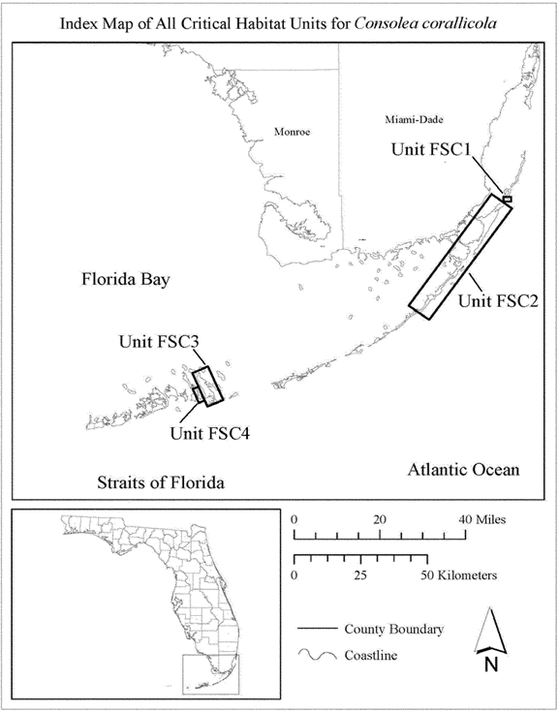

(6) Unit FSC1: Swan Key, Biscayne National Park, Miami-Dade County, Florida.

1. Unit FSC1 consists of 37 ac (15 ha) in Miami-Dade County. This unit is composed entirely of lands in Federal ownership, 100 percent of which are located on Swan Key within Biscayne National Park. The unit includes all upland rockland hammock habitat on Swan Key, most of which is located on the eastern side of Swan Key, surrounded by the island's mangrove fringe. A second, smaller area is located on the island's elongated western half and is also surrounded by mangroves. **[*3340]**
2. Map of Unit FSC1 follows:

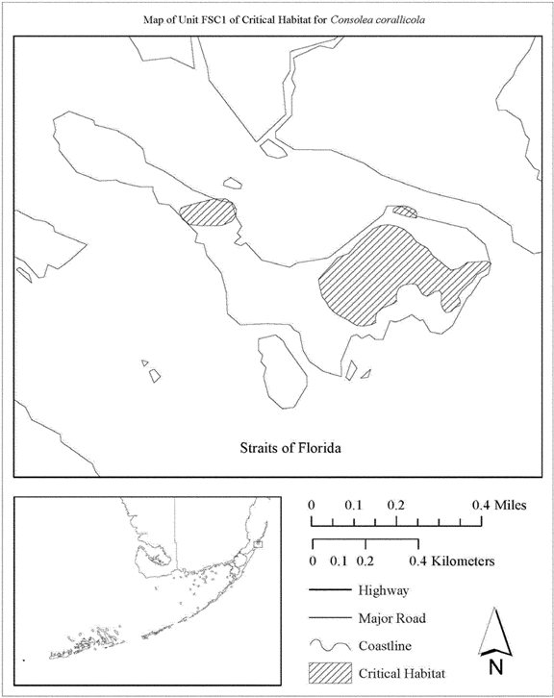

1. Unit FSC2: Key Largo, Monroe County, Florida.
2. Unit FSC2 consists of 3,434 ac (1,389 ha) in Monroe County. This unit is composed of Federal lands within Crocodile Lake National Wildlife Refuge (NWR) (702 ac (284 ha)); State lands within Dagny Johnson Botanical State Park, John Pennekamp Coral Reef State Park, and the Florida Keys Wildlife and Environmental Area (2331 ac (943 ha)); lands owned by Monroe County (17 ac (7 ha)); and parcels in private or other ownership (384 ac (155 ha)). This unit extends from near the northern tip of Key Largo, along the length of Key Largo, beginning at the south shore of Ocean Reef Harbor near South Marina Drive and the intersection of County Road (CR) 905 and Clubhouse Road on the west side of CR 905, and between CR 905 and Old State Road 905, then extending to the shoreline south of South Harbor Drive. The unit then continues on both sides of CR 905 through the Crocodile Lake NWR, Dagny **[*3341]** Johnson Key Largo Hammock Botanical State Park, and John Pennekamp Coral Reef State Park. The unit then terminates near the junction of U.S. 1 and CR 905 and Garden Cove Drive. The unit resumes on the east side of U.S. 1 from South Andros Road to Key Largo Elementary; then from the intersection of Taylor Drive and Pamela Street to Avenue A, then from Sound Drive to the intersection of Old Road and Valencia Road, then resumes on the east side of U.S. 1 from Hibiscus Lane and Ocean Drive. The unit continues south near the Port Largo Airport from Poisonwood Road to Bo Peep Boulevard. The unit resumes on the west side of U.S. 1 from the intersection of South Drive and Meridian Avenue to Casa Court Drive. The unit then continues on the west side of U.S. 1 from the point on the coast directly west of Peace Avenue south to Caribbean Avenue. The unit also includes a portion of the barrier island (El Radabob Key) in Largo Sound located directly east of Avenue A, extending south to a point directly east of Mahogany Drive. **[*3342]**
3. Index map of Unit FSC2 follows:

BILLING CODE 4310-55-P

**[*3343]**

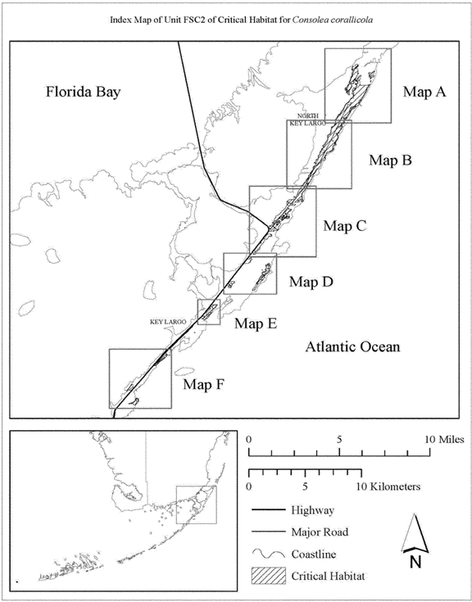

**[*3343]**



1. Map A of Unit FSC2 follows:

**[*3344]**

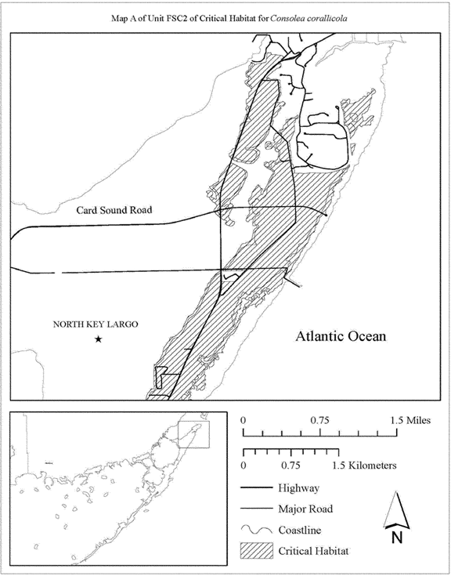

**[*3344]**



1. Map B of Unit FSC2 follows:

**[*3345]**

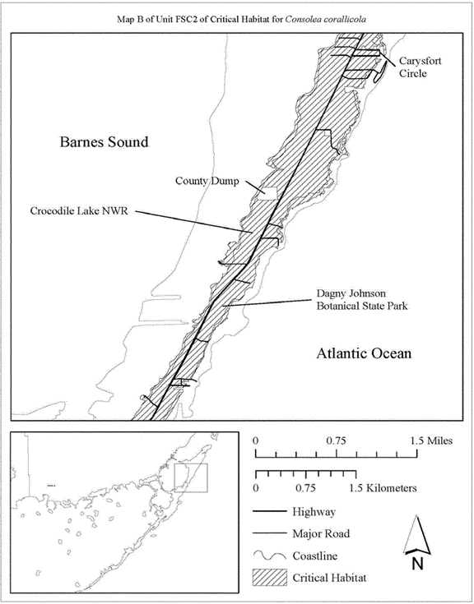

**[*3345]**



1. Map C of Unit FSC2 follows:

**[*3346]**

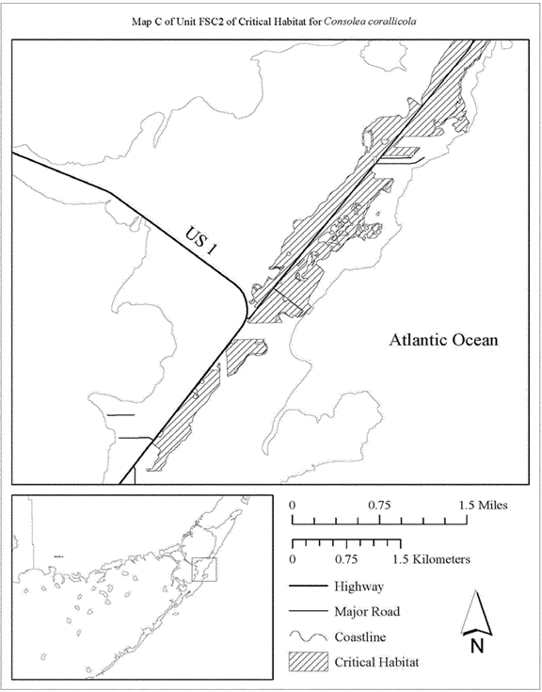

**[*3346]**



1. Map D of Unit FSC2 follows:

**[*3347]**

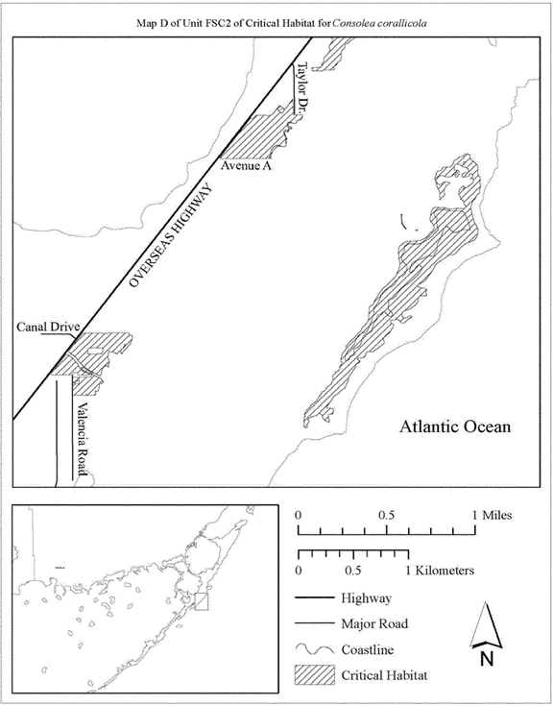

**[*3347]**



1. Map E of Unit FSC2 follows:

**[*3348]**

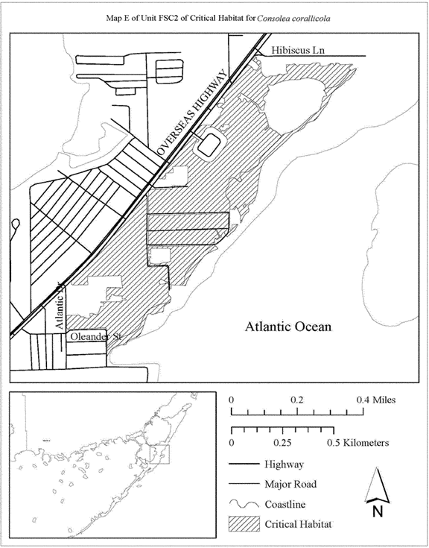

**[*3348]**



1. Map F of Unit FSC2 follows:

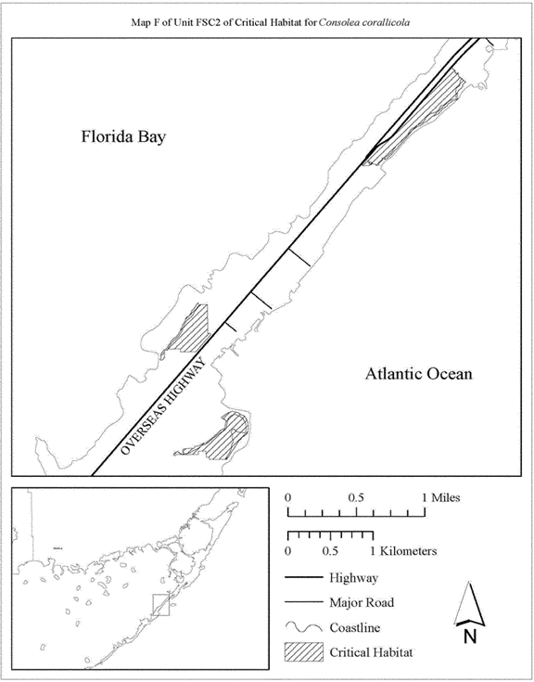

1. Unit FSC3: Big Pine Key, Monroe County, Florida.
2. Unit FSC3 consists of 772 ac (313 ha) in Monroe County. This unit is composed of Federal land within the National Key Deer Refuge (NKDR) (508 ac (205 ha)), State land managed as part of the NKDR (172 ac (70 ha)), lands owned by Monroe County (11 ac (5 ha)), and parcels in private or other ownership (81 ac (33 ha)). This unit extends from near the northern tip of Big Pine Key along the eastern shore to the vicinity of Hellenga Drive and Watson Road; from Gulf Boulevard south to West Shore Drive; Big Pine Avenue and Elma Avenues on the east, Coral and Yacht Club Road, and U.S. 1 on the north, and Industrial Avenue on the east from the southeastern tip of Big Pine Key to Avenue A. **[*3349]**
3. Index map of Unit FSC3 follows:

**[*3350]**

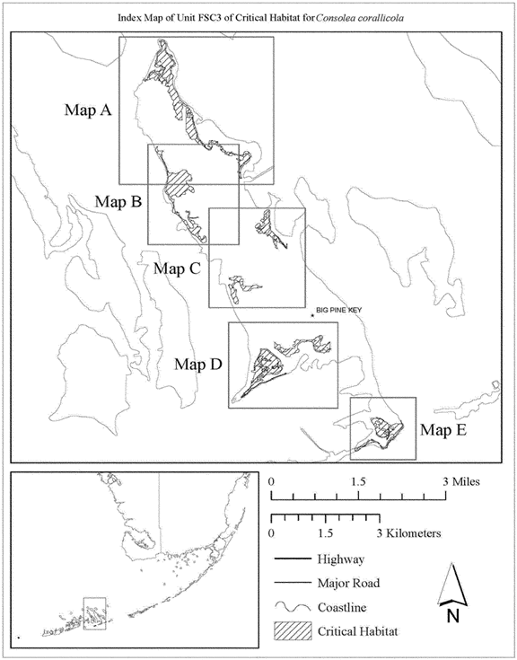

**[*3350]**



1. Map A of Unit FSC3 follows:

**[*3351]**

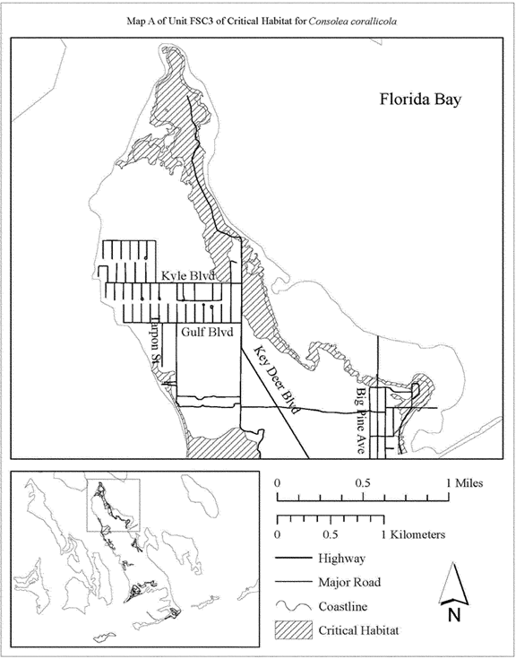

**[*3351]**



1. Map B of Unit FSC3 follows:

**[*3352]**

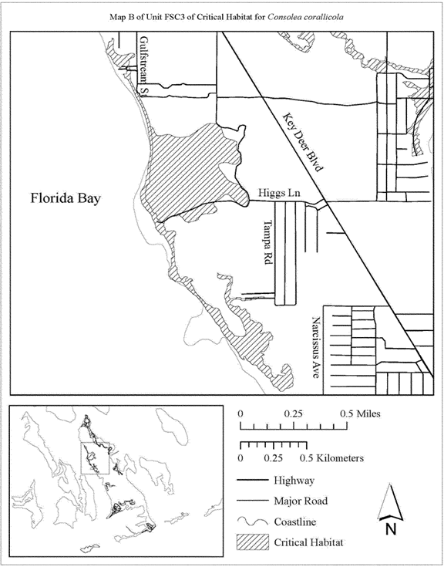

**[*3352]**



1. Map C of Unit FSC3 follows:

**[*3353]**

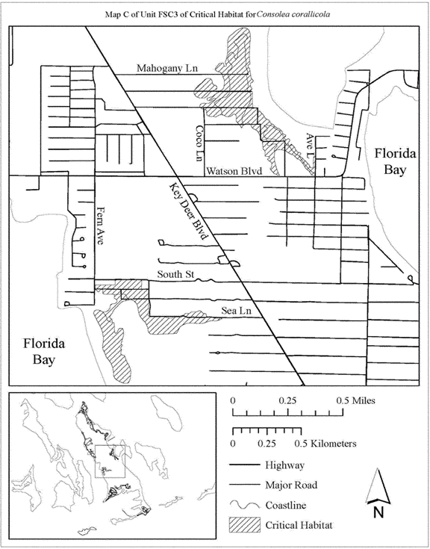

**[*3353]**



1. Map D of Unit FSC3 follows:

**[*3354]**

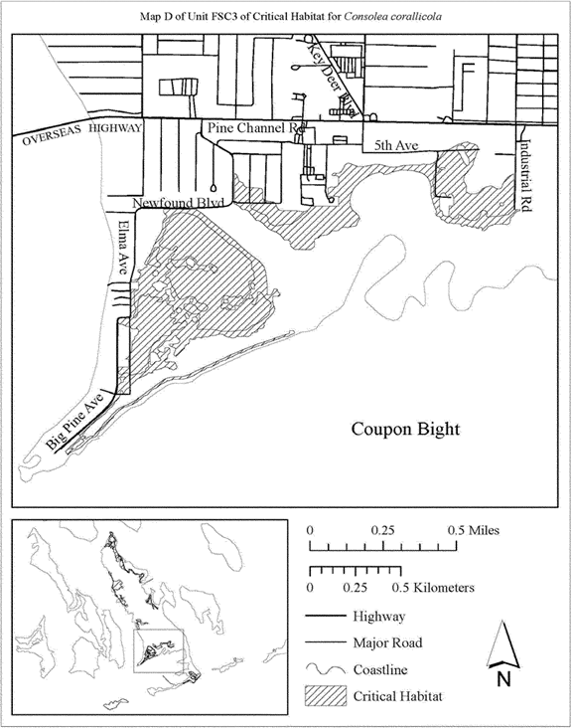

**[*3354]**



1. Map E of Unit FSC3 follows:

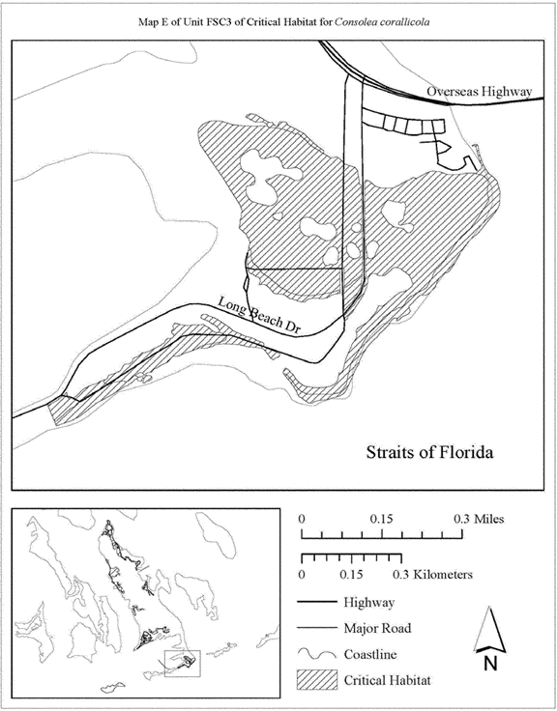

1. Unit FSC4: Little Torch Key, Monroe County, Florida.
2. Unit FSC4 consists of 168 ac (68 ha) in Monroe County. This unit is composed of State lands (47 ac (19 ha)), lands owned by Monroe County (10 ac (4 ha)), and parcels in private and other ownership (111 ac (45 ha)). This unit extends along State Highway 4A, from Coral Shores Road, south to County Road, resuming at Linda Street and extending south to the Overseas Highway. South of the Overseas Highway, the unit includes areas west of Kings Cove Road, and an area comprising the southern tip of Little Torch Key that includes portions of the John J. Pescatello Torchwood Hammock Preserve. **[*3355]**
3. Index map of Unit FSC4 follows:

**[*3356]**

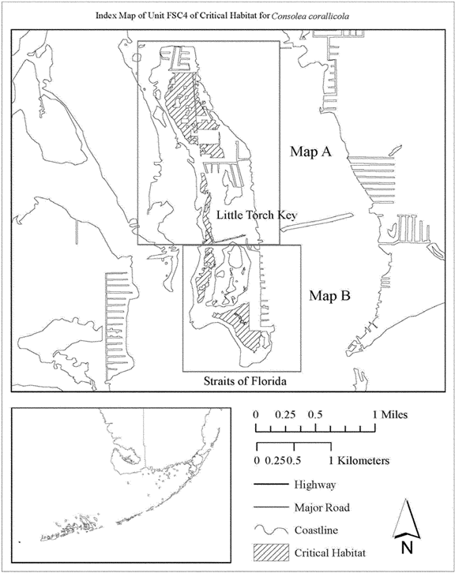

**[*3356]**



1. Map A of Unit FSC4 follows:

**[*3357]**

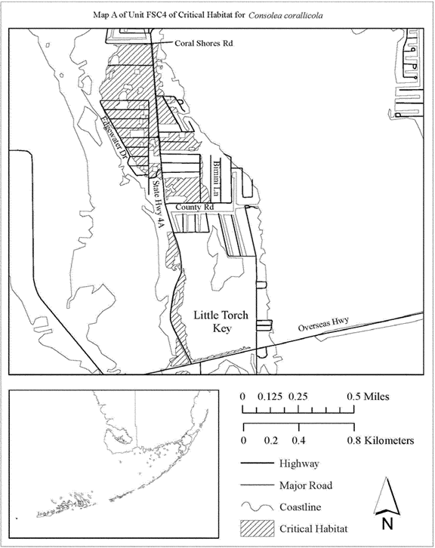

**[*3357]**



1. Map B of Unit FSC4 follows:

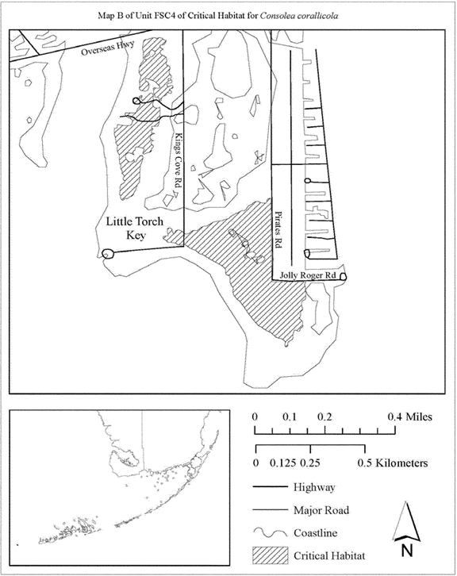

   *    *    *    *    *

Family Cactaceae: *Harrisia aboriginum* (Aboriginal Prickly-Apple)

1. Critical habitat units for *Harrisia aboriginum* are depicted for Manatee, Charlotte, Sarasota, and Lee Counties, Florida, on the maps below.
2. Within these areas, the primary constituent elements of the physical or biological features essential to the conservation of *Harrisia aboriginum* are:
3. Areas of upland habitats consisting of coastal strand, coastal grassland, coastal berm, maritime hammocks, and shell mounds.
4. Coastal strand habitat that contains:
5. Open to semi-open canopy and understory, and
6. Substrate of sand and shell fragments of stabilized coastal dunes.
7. Coastal grassland habitat that contains: **[*3358]**
8. No canopy and an open understory, and
9. Substrate of sand and shell fragments.
10. Coastal berm habitat that contains:
11. Open to semi-open canopy, subcanopy, and understory, and
12. Substrate of coarse, calcareous, storm-deposited sediment.
13. Maritime hammock habitat that contains:
14. Canopy gaps and edges with an open to semi-open canopy, subcanopy, and understory; and
15. Substrate of calcareous sand and shell fragments.
16. Shell mound habitat that contains:
17. Open to semi-open canopy and understory, and
18. Substrate of soil derived from calcareous shells deposited by Native Americans during prehistoric times.
19. A plant community of predominately native vegetation with no invasive, nonnative animal or plant species or such species in quantities low enough to have minimal effect on survival of *Harrisia aboriginum.*
20. Canopy openings in coastal strand, coastal grassland, coastal berm, maritime hammock, and shell mound habitats that are created by the effects of strong winds or saltwater inundation from storm surge or infrequent tidal inundation.
21. Habitats that are connected and of sufficient size to sustain viable populations in coastal strand, coastal grassland, coastal berm, maritime hammock, and shell mound habitats.
22. Habitats that provide populations of the generalist pollinators that visit the flowers of *Harrisia aboriginum.*
23. Critical habitat does not include manmade structures (such as buildings, aqueducts, runways, roads, and other paved areas) and the land on which they are located that exists within the legal boundaries on the effective date of this rule.
24. ***.***Unit maps were developed using ESRI ArcGIS mapping software along with various spatial data layers. ArcGIS was also used to calculate area. The projection used in mapping and calculating distances and locations within the units was North American Albers Equal Area Conic, NAD 83. The maps in this entry, as modified by any accompanying regulatory text, establish the boundaries of the critical habitat designation. The coordinates or plot points or both on which each map is based are available to the public at the Service's Internet site at [*http://www.fws.gov/verobeach/*](http://www.fws.gov/verobeach/)*,* at [*http://www.****regulations****.gov*](http://www.regulations.gov) at Docket No. FWS-R4-ES-2014-0057, and at the field office responsible for this designation. You may obtain field office location information by contacting one of the Service regional offices, the addresses of which are listed at [*50 CFR 2.2*](https://advance.lexis.com/api/document?collection=administrative-codes&id=urn:contentItem:5SY6-K7K0-008H-01VM-00000-00&context=). **[*3359]**
25. Index map of all critical habitat units for *Harrisia aboriginum* follows:

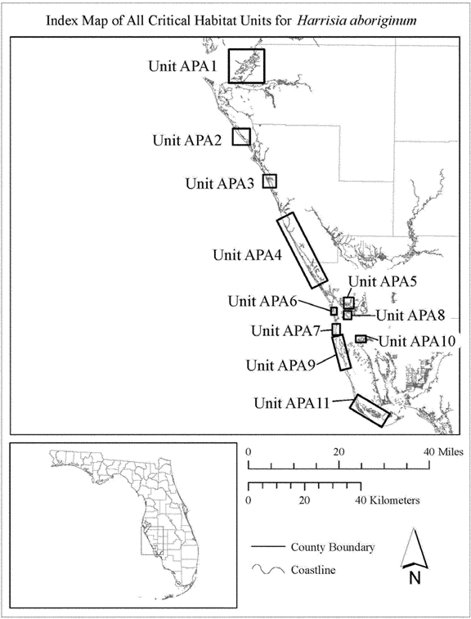

1. Unit APA1: Terra Ceia, Manatee County, Florida.
2. Unit APA1 consists of approximately 222 ac (90 ha) in Manatee County, Florida. This unit is composed of State lands within Madira Bickel Mound State Historical Park, Terra Ceia Preserve State Park, Cockroach Bay State Buffer Preserve, and the Tampa Bay Estuarine System, (66 ac (27 ha)); Manatee County lands at Emerson Point Preserve and parcels owned by the Manatee County Port Authority (70 ac (28 ha)); and parcels in private or other ownership (87 ac (35 ha)). This unit includes lands west of Highway 41 extending from just south of South Dock Street south to Snead Island. The unit also includes areas of Harbor Key, Mariposa Key, Horseshoe **[*3360]** Key, Joe Island, Skeet Key, Paradise Island, Ed's Key, and Rattlesnake Key.
3. Index map of Unit APA1 follows:

**[*3361]**

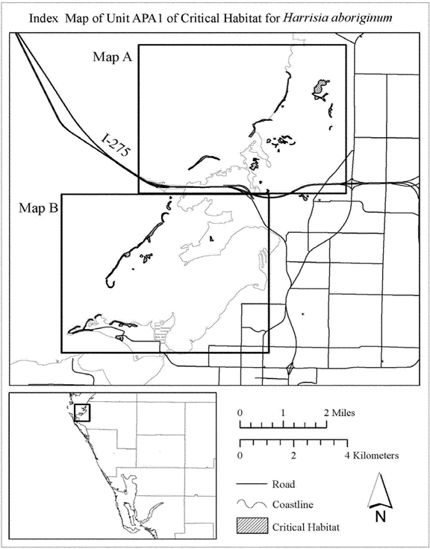

**[*3361]**



1. Map A of Unit APA1 follows:

**[*3362]**

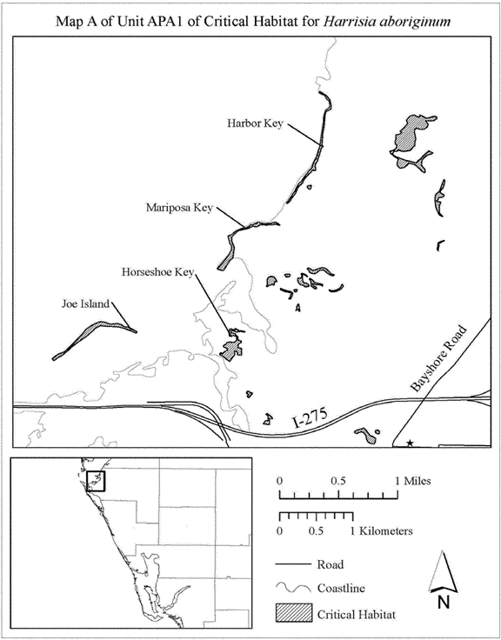

**[*3362]**



1. Map B of Unit APA1 follows:

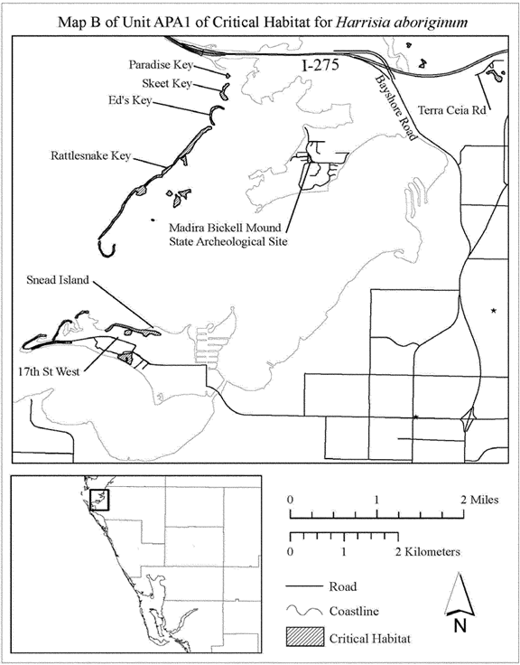

1. Unit APA2: Longboat Key, Sarasota County, Florida.
2. Unit APA2 consists of approximately 54 ac (22 ha) in Sarasota County, Florida. This unit is composed entirely of parcels in private or other ownership. This unit includes lands west of Gulf of Mexico Drive, extending from 0.40 mi (0.6 km) south of the intersection of Bay Isles Parkway and Gulf of Mexico Drive, to the southern tip of Longboat Key. It also includes lands on the north side of Gulf of Mexico Drive, east of Longboat Club Key Drive, on the northwest tip of Longboat Key. **[*3363]**
3. Map of Unit APA2 follows:

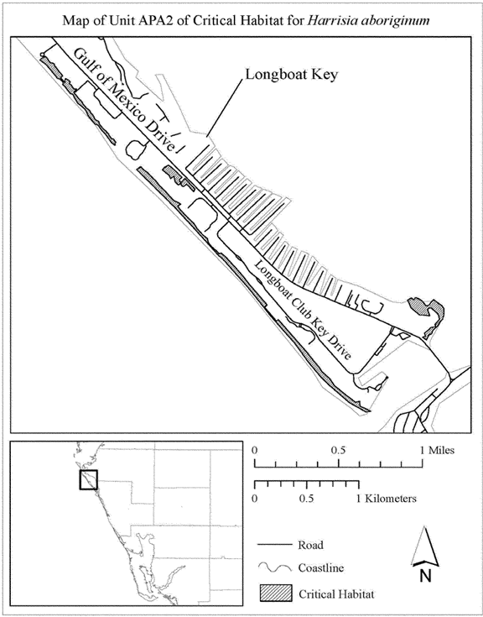

1. Unit APA3: Osprey, Sarasota County, Florida.
2. Unit APA3 consists of approximately 116 ac (47 ha) in Sarasota County, Florida. This unit is composed of Sarasota County lands within Palmer Point County Park (50 ac (20 ha)) and parcels in private or other ownership (66 ac (27 ha)). This unit extends along the barrier island (Casey Key) from the south terminus of Blind Pass Road, south for approximately 1.2 mi (1.9 km) along North Casey Key Road. On the mainland, the unit includes lands bordered on the north by Vamo Way, to the east by Highway 41, and to the south by Palmetto Avenue. **[*3364]**
3. Map of Unit APA3 follows:

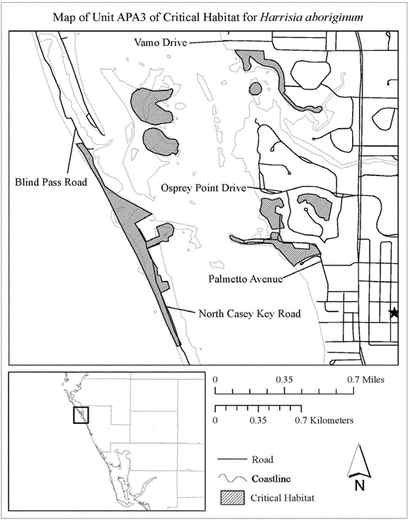

1. Unit APA4: Manasota Key, Sarasota and Charlotte Counties, Florida.
2. Unit APA4 consists of approximately 415 ac (168 ha) in Sarasota and Charlotte Counties, Florida. This unit is composed of State lands within Stump Pass Beach State Park (58 ac (23 ha)); County lands within Blind Pass Park, Brohard Beach and Paw Park, Manasota Beach Park, Casperson Beach Park, and Service Club Park (111 ac (45 ha)); and parcels in private or other ownership (245 ac (99 ha)). This unit extends from Beach Road in the City of Venice, south along Manasota Key to the barrier islands southern tip, including a portion of Peterson Island. **[*3365]**
3. Index map of Unit APA4 follows:

**[*3366]**

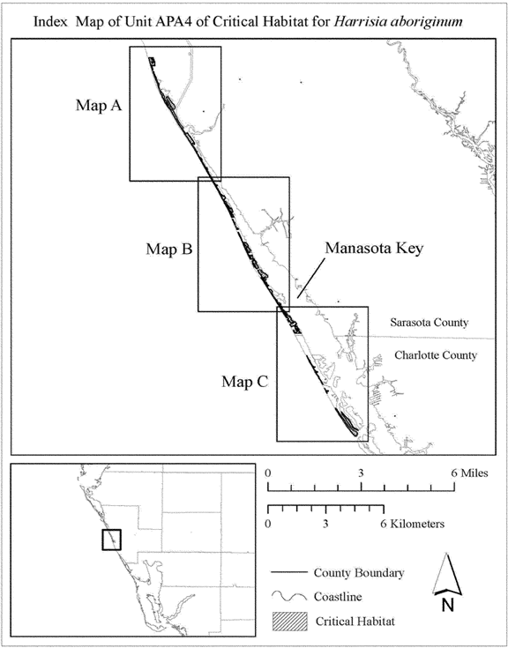

**[*3366]**



1. Map A of Unit APA4 follows:

**[*3367]**

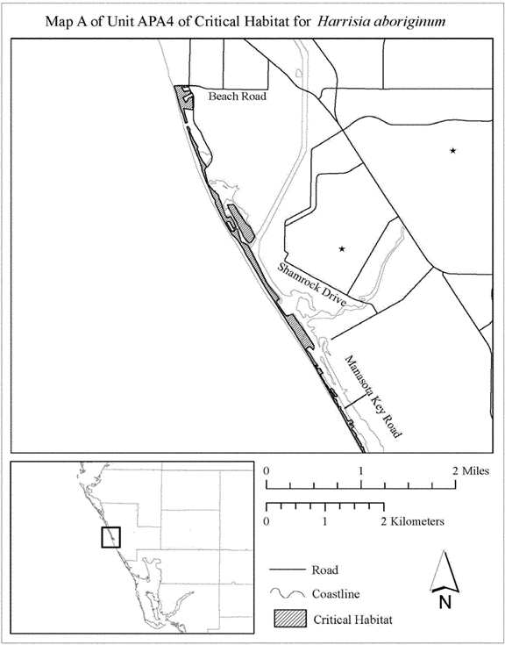

**[*3367]**



1. Map B of Unit APA4 follows:

**[*3368]**

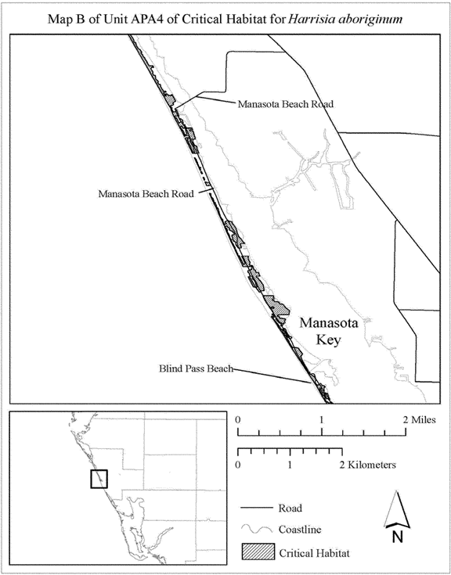

**[*3368]**



1. Map C of Unit APA4 follows:

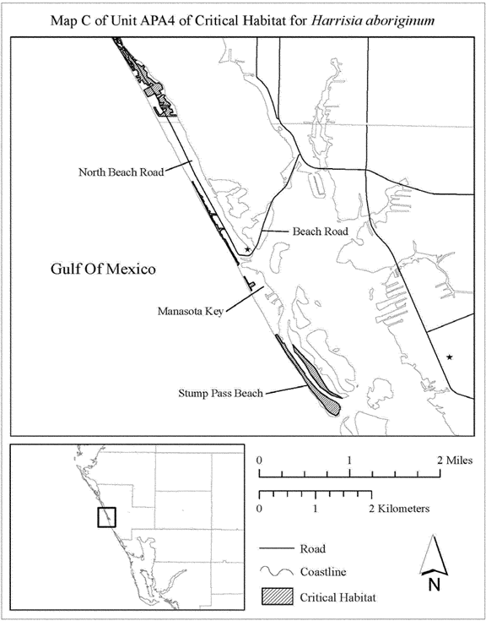

1. Unit APA5: Charlotte Harbor, Charlotte County, Florida.
2. Unit APA5 consists of 51 ac (21 ha) in Charlotte County, Florida. This unit is composed entirely of State lands within the Charlotte Harbor Preserve State Park. This unit includes the Big Mound, Boggess Ridge, and a shell mound located on the east side of Charlotte Harbor, south of the City of Charlotte Park. **[*3369]**
3. Map of Unit APA5 follows:

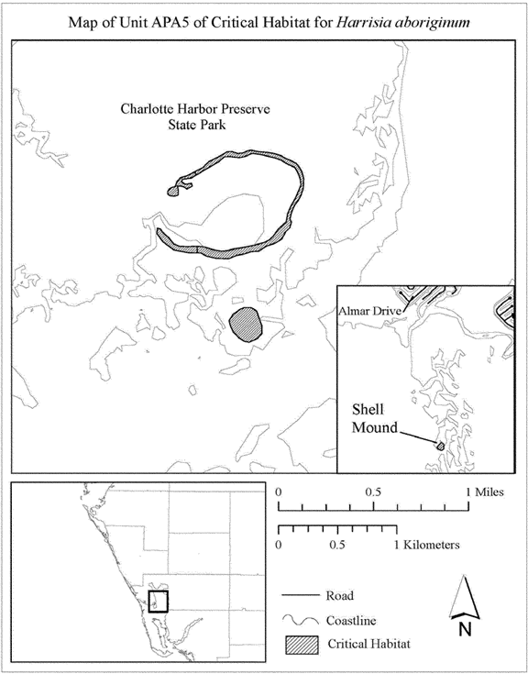

1. Unit APA6: Gasparilla North, Charlotte and Lee Counties, Florida.
2. Unit APA6 consists of approximately 98 ac (40 ha) in Charlotte and Lee Counties, Florida. This unit is composed of State land (0.006 ac (0.02 ha)), county land (22 ac (9 ha)), and parcels in private or other ownership (77 ac (31 ha)). This unit includes most of Kitchen Key (Live Oak Key) and the area east of Gasparilla Road, from the intersection of Grouper Hole Road and Grouper Hole Court, south to 0.15 mi (0.24 km) north of Snail Island Court, from approximately 0.10 mi (0.21 km) south of 35th Street to 23rd Street, including the small island separated from Gasparilla Island by a canal; and from 22nd Street to 20th Street. **[*3370]**
3. Map of Unit APA6 follows:

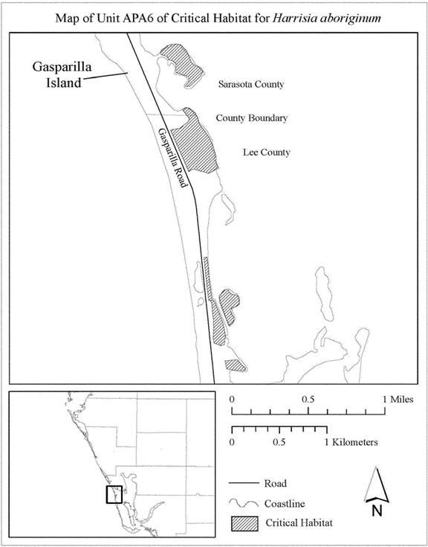

1. Unit APA7: Gasparilla South, Lee County, Florida.
2. Unit APA7 consists of approximately 92 ac (37 ha) in Lee County, Florida. This unit is composed of Federal land owned by the Service and Bureau of Land Management (3 ac (1 ha)), State lands within Gasparilla Island State Park (69 ac (28 ha)), Lee County lands (12 ac (5 ha), and parcels in private or other ownership (8 ac (3 ha)). This unit includes lands located from south of 1st Street to the southern tip of Gasparilla Island. **[*3371]**
3. Map of Unit APA7 follows:

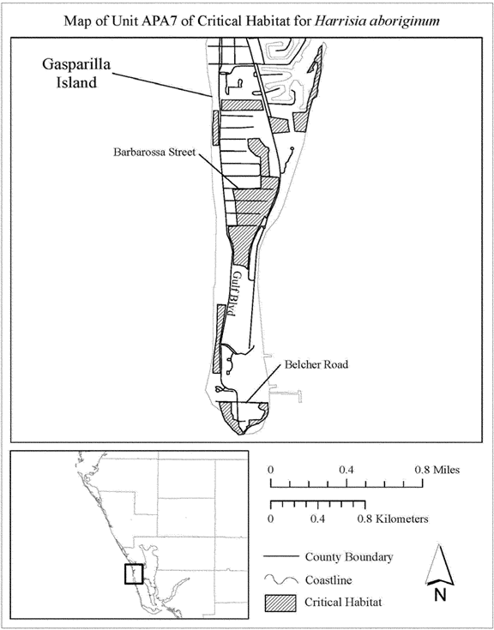

1. Unit APA8: Cayo Pelau, Lee County, Florida.
2. Unit APA8 consists of approximately 25 ac (10 ha) in Charlotte and Lee Counties, Florida. This unit is composed of Lee County lands within Cayo Pelau Preserve, and parcels in private or other ownership (0.6 ac (0.2 ha)). This unit includes lands located from 0.13 mi (0.21 km) south of the northern tip of Cayo Pelau, extending south to the southeastern tip of Cayo Pelau. **[*3372]**
3. Map of Unit APA8 follows:

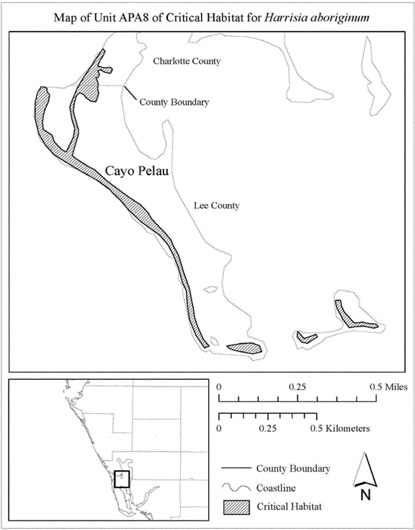

1. Unit APA9: Cayo Costa, Lee County, Florida.
2. Unit APA9 consists of approximately 1,702 ac (689 ha) in Lee County, Florida. This unit is composed of State lands within Cayo Costa State Park (1,379 ac (558 ha)), lands owned by Lee County (94 ac (38 ha)), and parcels in private or other ownership (230 ac (93 ha)). This unit includes lands located from the northern tip to the southern tip of Cayo Costa. **[*3373]**
3. Map of Unit APA9 follows:

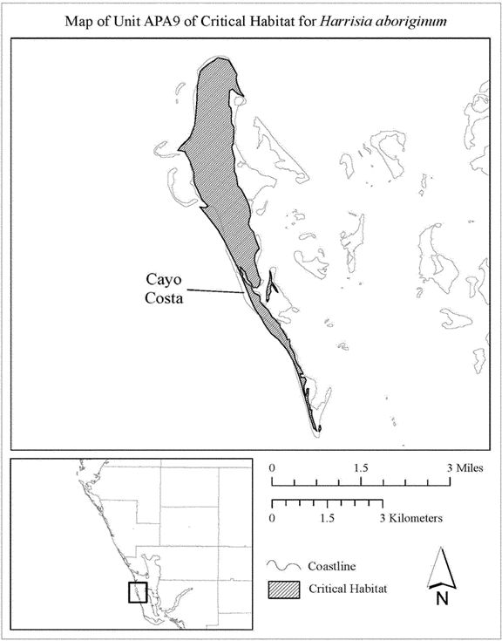

1. Unit APA10: Bocilla, Lee County, Florida.
2. Unit APA10 consists of approximately 33 ac (13 ha) in Lee County, Florida. This unit is composed of Lee County lands within the Bocilla Preserve (32 ac (13 ha)) and parcels in private or other ownership (0.7 ac (0.3 ha)). This unit includes lands located on the undeveloped portion of Bokeelia Island from 0.02 mi (0.03 km) west of the terminus of Ebbtide Way, extending south and west to the northwestern and southeastern corners of Bokeelia Island. **[*3374]**
3. Map of Unit APA10 follows:

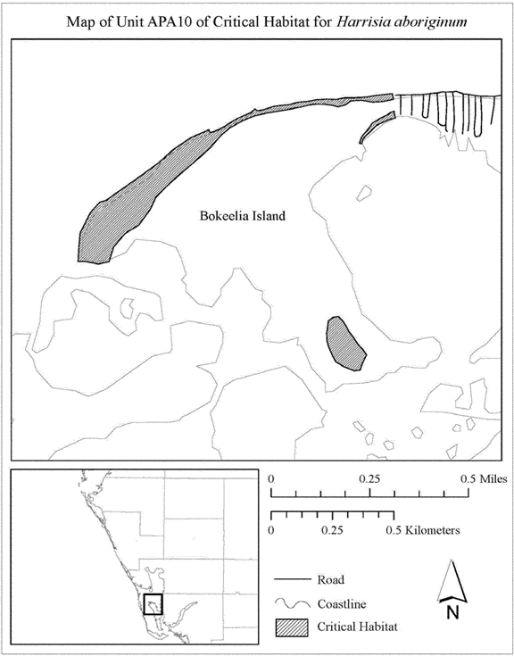

1. Unit APA11: Sanibel Island and Buck Key, Lee County, Florida.
2. Unit APA11 consists of approximately 635 ac (257 ha) in Lee County, Florida. This unit is composed of Federal lands owned by the Bureau of Land Management, and Service lands within the J.N. Ding' Darling National Wildlife Refuge (NWR) (373 ac (151 ha)), State lands (47 ac (19 ha)), lands owned by Lee County (90 ac (36 ha)), and parcels in private or other ownership (126 ac (51 ha)). This unit includes lands on Buck Key, Runyan Key, and Sanibel Island. On Sanibel Island, the unit includes a portion of Bowman's Beach, from just south of Silver Key to the western terminus of Water's Edge Lane; uplands within J.N. Ding' Darling NWR; and a shell mound located near the northern terminus of Tarpon Bay Road. **[*3375]**
3. Index map of Unit APA11 follows:

**[*3376]**

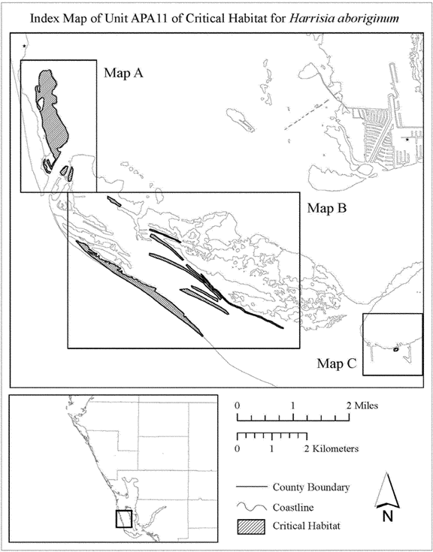

**[*3376]**



1. Map A of Unit APA11 follows:

**[*3377]**

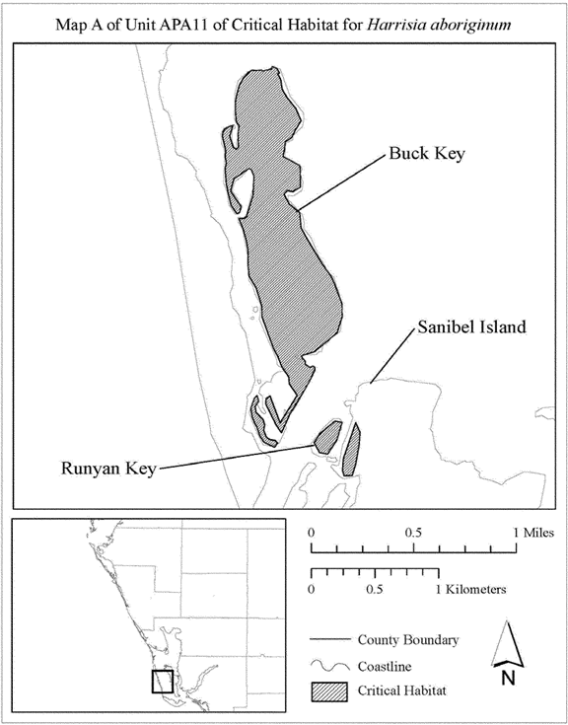

**[*3377]**



1. Map B of Unit APA11 follows:

**[*3378]**

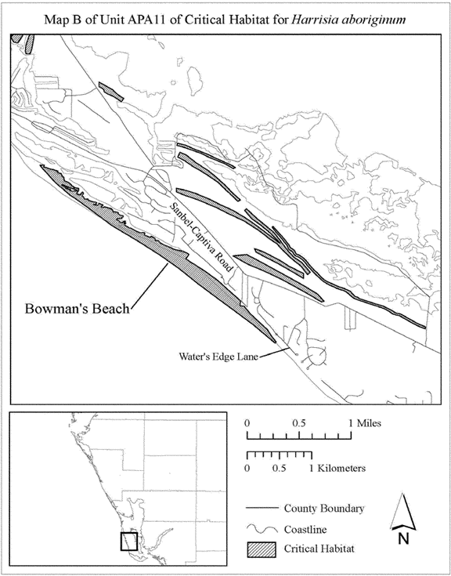

**[*3378]**



1. Map C of Unit APA11 follows:

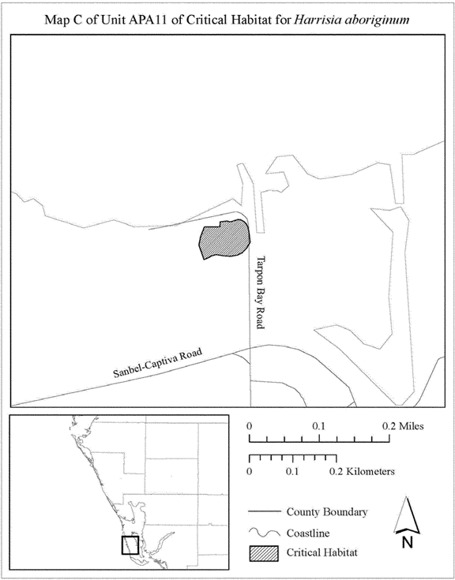

   *    *    *    *    *

Dated: December 18, 2014.

**Michael Bean,**

*Principal Deputy Assistant Secretary for Fish and Wildlife and Parks.*

[FR Doc. 2015-00344 Filed 1-21-15; 8:45 am]

BILLING CODE 4310-55-C

**Dates**

**DATES:** We will accept comments received or postmarked on or before March 23, 2015. Comments submitted electronically using the Federal eRulemaking Portal (see **ADDRESSES** below) must be received by 11:59 p.m. Eastern Time on the closing date. We must receive requests for public hearings, in writing, at the address shown in **ADDRESSES** by March 9, 2015.

**Contacts**

**ADDRESSES:** You may submit comments by one of the following methods:

(1) *Electronically:* Go to the Federal eRulemaking Portal: [*http://www.****regulations****.gov*](http://www.regulations.gov)*.* In the Keyword box, enter FWS-R4-ES-2014-0057, which is the docket number for this rulemaking. Then, in the Search panel on the left side of the screen, under the Document Type heading, click on the Proposed Rules link to locate this document. You may submit a comment by clicking on "Comment Now!"

(2) *By hard copy:* Submit by U.S. mail or hand-delivery to: Public Comments Processing, Attn: FWS-R4-ES-2014-0057; U.S. Fish and Wildlife Service Headquarters, MS: BPHC, 5275 Leesburg Pike, Falls Church, VA 22041-3803.

We request that you send comments only by the methods described above. We will post all comments on [*http://www.****regulations****.gov*](http://www.regulations.gov)*.* This generally means that we will post any personal information you provide us (see Information Requested below for more information).

The coordinates, plot points, or both from which the maps are generated are included in the administrative record for this critical habitat designation and are available at [*http://www.fws.gov/verobeach/*](http://www.fws.gov/verobeach/)*,* at [*http://www.****regulations****.gov*](http://www.regulations.gov) at Docket No. FWS-R4-ES-2014-0057, and at the South Florida Ecological Services Office (see **FOR FURTHER INFORMATION CONTACT**). Any additional tools or supporting information that we may develop for this critical habitat designation will also be available at the U.S. Fish and Wildlife Service Web site and Field Office set out above, and may also be included in the preamble and/or at [*http://www.****regulations****.gov*](http://www.regulations.gov)*.*

**FOR FURTHER INFORMATION CONTACT:** Acting Field Supervisor Roxanna Hinzman, U.S. Fish and Wildlife Service, South Florida Ecological Services Office, 1339 20th Street, Vero Beach, FL 32960; by telephone 772-562-3909; or by facsimile 772-562-4288. If you use a telecommunications device for the deaf (TDD), call the Federal Information Relay Service (FIRS) at 800-877-8339.

FEDERAL REGISTER

**End of Document**